Promenade East Condominium Association
dba Promenade Towers
Annual Meeting
September 11, 2019

Directors Present: Jim Zafirson, Megan Ladd, Nick Ciciretti, Andy Glassberg, Mark Rockwood, and Jeff von Munkwitz-Smith

Directors Absent: Dave Mathieu

- The meeting was called to order at approximately 7:00 PM in the Promenade Towers Community Room by President Jim Zafirson.

- Roll call was taken with the following results: There were a total of 50 (out of 80) owners either in person (20) or represented by proxy (30). These 50 represented 62.03 percent of ownership interest.

- Proof of Notice: Nick Ciciretti presented Proof of Notice.

- Minutes of the September 12, 2018 Annual Association Meeting were approved as written.

- President’s Report: Mr. Zafirson made note of the strong sense of community at Prom Towers and thanked the Association board for their work and the members for their interest and involvement. He also gave a special thanks to Dave DeBree for his high level of professionalism as property manager.

- Treasurer’s Report: Ms.Ladd reported the following –

- The Operating account balance is $68,886 and the Reserve account balance is $684,864 as of August 31, 2019. The Operating balance is temporarily inflated due to funds not being transferred to the Reserve account. This will be rectified in subsequent months.

- There will be insurance payments coming in due to the hot water heater leak in unit #222, which caused extensive damage in the building.

- Unfinished business:

- Elastomeric coating – Mr. Zafirson pointed out that the elastomeric coating on the building is still doing its job, but not looking good. We have received two bids to recoat the building, from Knowles ($175,000) and Haskell and Hall ($189,000). Knowles did the original coating on the building. A motion was made, seconded, and approved to award the contract to Knowles for the $175,000 bid. The work will begin approximately late April to early May of next year (2020).

- Andy Glassberg noted that the square footage for units with decks had been incorrect in the City of Portland records, but that those records have been corrected.

- New business:

- IRS 70-604 Election for 2019. As explained by Ms. Ladd, this is an annual election by the membership. She made a motion that any excess of membership income over membership expenses, for the tax year ending December 31, 2019, shall be applied against the subsequent tax year member assessments, as provided by IRS Revenue Ruling 70-604. The motion was seconded and approved by the members. Documentation is attached.

- Election of Board of Directors members. There were two open positions for the Board. The following individuals volunteered for these positions:

  - Megan Ladd
  - Judy Katzel

Mr. Zafirson invited each of the above to briefly introduce themselves. The candidates were elected by a show of hands.

The current Board members, listed by term expiration, are as follows -

Term Expires
Nick Ciciretti, Secretary 2020
Andy Glassberg 2020
Jim Zafirson, President 2021
Mark Rockwood 2021
Jeff von Munkwitz-Smith 2021
Megan Ladd, Treasurer 2022
Judy Katzel 2022

- The meeting was adjourned at approximately 7:20 PM.

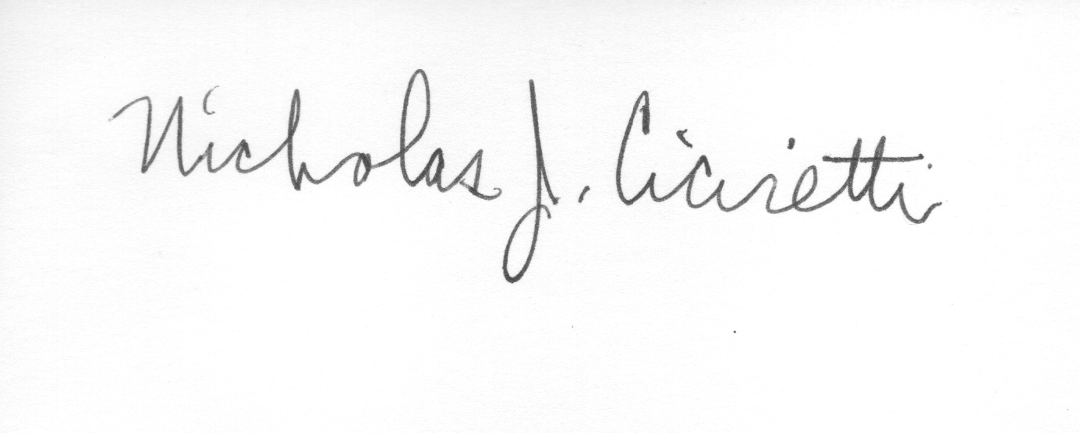
Nick Ciciretti
Secretary

Attachments: Resolution – IRS Ruling 70-604 Election

Directors Meeting
Election of Officers

A brief Directors Meeting was held immediately after the Annual Meeting at 7:25 PM in the Community Room. The following officers were elected for the coming year:

Jim Zafirson, President
Megan Ladd, Treasurer
Nick Ciciretti, Secretary

The meeting was adjourned at 7:35 PM.

Nick Ciciretti
Secretary

