Promenade East Condominium Association
dba Promenade Towers
Annual Meeting
September 9, 2020

Directors Present: Jim Zafirson, Megan Ladd, Nick Ciciretti, Andy Glassberg, Judy Katzel, Mark Rockwood, and Jeff von Munkwitz-Smith

- The meeting was called to order at approximately 7:00 PM in the pool area by President Jim Zafirson.

- Roll call was taken with the following results: There were a total of 41 (out of 80) owners either in person (7) or represented by proxy (34). These 41 represented 52.23 percent of ownership interest.

- Proof of Notice: Nick Ciciretti presented Proof of Notice.

- Minutes of the September 11, 2019 Annual Association Meeting were approved as written.

- President’s Report: Mr. Zafirson made note of the way the Prom Towers community came together in light of the pandemic, given all the changes that it engendered. He also noted improvements made to the building, most obviously the elastomeric recoating. Also, he introduced Dave Higham as the new property manager, replacing Dave DeBree

- Treasurer’s Report: Ms.Ladd reported the following –

- The Operating account balance is $33,444 and the Reserve account balance is $816,275 as of August 31, 2020.

- There has been a partial payment to Knowles as part of the elastomeric coating project

- Unfinished business:

- Andy Glassberg noted that the City of Portland records listed all units as having garage parking, but that has been corrected. He also stated that the traffic signal project at Walnut /Fox & Washington is proceeding.

- New business:

- IRS 70-604 Election for 2020. As explained by Ms. Ladd, this is an annual election by the membership. She made a motion that any excess of membership income over membership expenses, for the tax year ending December 31, 2020, shall be applied against the subsequent tax year member assessments, as provided by IRS Revenue Ruling 70-604. The motion was seconded and approved by the members. Documentation is attached.

- Ms. Ladd announced that she is relinquishing her position as treasurer and resigning from the board

- Election of Board of Directors members. There were three open positions for the Board. The following individuals volunteered for these positions:

  - Nick Ciciretti
  - Andy Glassberg
  - Gregg Turley

Mr. Zafirson invited each of the above to briefly introduce themselves. The candidates were elected by a show of hands.

The current Board members, listed by term expiration, are as follows -

Term Expires
Jim Zafirson, President 2021
Mark Rockwood 2021
Jeff von Munkwitz-Smith 2021
Judy Katzel 2022
Gregg Turley 2022
Nick Ciciretti, Secretary 2023
Andy Glassberg 2023

- Ms. Katzel noted that the Prom Towers website will be upgraded soon. Mr. Ciciretti agreed to be a back-up administrator for it. Also, Ms. Katzel said that she will be looking as ways to upgrade the picnic area. Mr. Turley offered to help with this endeavor.

- The meeting was adjourned at approximately 7:20 PM.

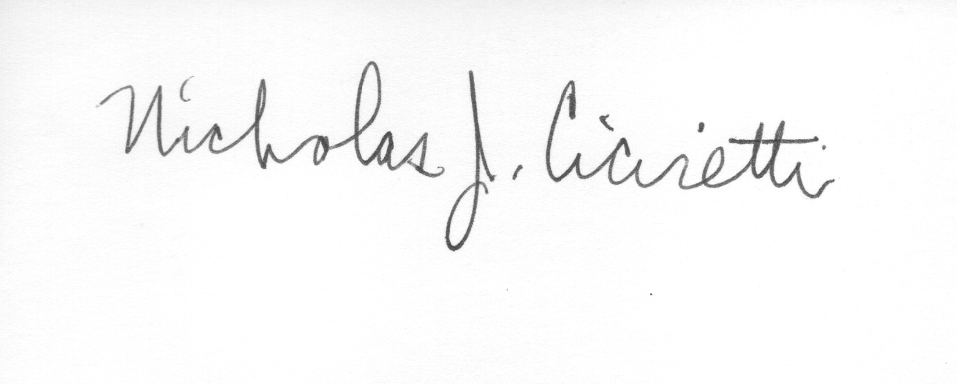
Nick Ciciretti
Secretary

Attachments: Resolution – IRS Ruling 70-604 Election

Directors Meeting
Election of Officers

A brief Directors Meeting was held immediately after the Annual Meeting at 7:25 PM in the pool area. The following officers were elected for the coming year:

Jim Zafirson, President
Jeff von Munkwitz-Smith, Treasurer
Nick Ciciretti, Secretary

The meeting was adjourned at 7:35 PM.

Nick Ciciretti
Secretary

