Directors Meeting Minutes
Promenade Towers
October 15, 2020

The meeting was held remotely via Zoom due to Covid-19 distancing guidelines

Directors present: Nick Ciciretti, Andy Glassberg, Judy Katzel, Mark Rockwood, Jeff von Munkwitz-Smith, Gregg Turley, and Jim Zafirson.

- The meeting was called to order at approximately 7:00 PM.

- The meeting minutes from August 20, 2020 were approved as written.

- Treasurer’s Report:
  - Jeff von Munkwitz-Smith presented a summary of our income and expenses through September. The Operating account balance was $39,325 and the Reserve balance was $746,469 as of September 30, 2020.
  - Jeff also presented the budget for 2021. It will be voted on at the next Board meeting.

- Unfinished Business:
- Elastomeric coating project – The project is almost completed. It was noted that the deck railings need to be repainted but that this was not part of the scope of the contract with Knowles. Painting of the railings will be addressed in the spring.
- Covid-19 protocols – Supplies for cleaning stations (wipes, sanitizer, etc.) will be purchased ahead to ensure an adequate supply for the next six months. Since the elevator fans have been set to run constantly, Pine State Elevator will be contacted regarding their expected lifetime; replacement parts may be ordered soon in anticipation of fan failure. Dave Higham will conduct a walk-through to determine where carpet spot cleaning will be needed. One area noted was the carpet in elevator #1. Since unit inspections have been put on hold, batteries for door locks and hot water heater alarms of board members will be tested to determine useful life and to establish a timetable for replacement in all units. Gregg will address this.
- Website improvements – There is a meeting scheduled for October 22nd with the web designer, Judy, and Nick. There was discussion about possible addition of a messaging board, an FAQ section, and an electronic bulletin board. Although no final decisions were made it was agreed that an FAQ section might be the most appropriate addition.
- Installation of ice clips on parking area across from entrance – R & E will install clips before snow season commences.
- US Cellular tower upgrade – Jim has gotten agreement with US Cellular on the following specifications: all additions will be within the same footprint; antennas will be unshrouded and painted to match existing paint; existing chases will be used for new cables and painted as needed; the fence at the bottom of the tower will be repainted; there will be a pre- and post-upgrade inspection of the roof by the Association’s roofer; and there will be pre- and post-upgrade radiation (RF) testing, with earlier testing providing a baseline.
- Update on improvements to Sprint equipment – There has been nothing new regarding this.
- Water shutoff access panels – Work will be done in the spring. It will also include an evaluation of valves currently in place.
- Replacement of three air conditioning units – It was noted that air conditioning systems in the building date to 1975. There was discussion about exploring replacement with heat pumps, but there are structural issues which would lead to costs being prohibitive. Until heat pump technology improves to allow units to fit in available space, this option is not viable.
- Hot water heater shutoff recommendation and cost sharing – There has been nothing new regarding this.

- New Business:
- Diseased trees near pool – Gregg reported that an arborist from the State of Maine visited and made recommendations regarding the trees, their condition (not immediately life-threatening), and the surrounding soil and vegetation. McGarvey has been contacted about the cost of completing the recommendations. There is some question about where the Prom Tower property line actually ends and whether the City of Portland may bear some responsibility regarding the trees. Gregg and Andy will explore this.
- Pool tile repair/refinishing – Christman has given prices for several different jobs including tile replacement, installation of an auto leveler, and complete replacement of gunnite and plaster. No final decisions were made at this time.
- Air purifier for fitness room – Gregg has investigated this and presented information on a unit which has a HEPA filtration system along with a UV light which would kill organisms and provide some odor control. The unit would be on a timer set to run from 5 am to 10 pm. A motion was made, seconded, and approved to purchase the unit and UV light (approximately $1000). Expected yearly maintenance costs are approximately $250.
- Combining November/December Board meetings – A motion was made, seconded, and approved to combine the Board meetings to be held on the regularly scheduled November meeting date of November 19.

- Property Manager report:
  - Troiano has provided new dumpsters. The new recycling dumpster is 4 cubic yards (twice the size of the old dumpster).
  - A new camera has been installed at the end of the far covered parking area in the middle lot.
  - New motion-sensor lights have been installed in the covered parking lot under building 2 and in the covered parking area where the new camera was installed.
  - Window washing, which was planned to be done as part of the coating project, may not be done until the spring, but all external windows will be washed as part of the coating project.

- Meeting was adjourned at 9:05 PM.

Executive session – An executive session was held following the meeting to discuss insurance and liability issues.

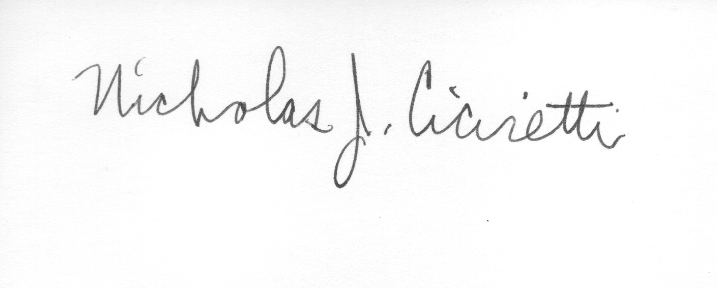
Nick Ciciretti
Secretary

