Directors Meeting Minutes
Promenade Towers
November 19, 2020

The meeting was held remotely via Zoom due to Covid-19 distancing guidelines

Directors present: Nick Ciciretti, Andy Glassberg, Judy Katzel, Mark Rockwood, Jeff von Munkwitz-Smith, Gregg Turley, and Jim Zafirson.

- The meeting was called to order at approximately 7:00 PM.

- The meeting minutes from October 15, 2020 were approved as written.

- Treasurer’s Report:
  - Jeff von Munkwitz-Smith presented a summary of our income and expenses through October. The Operating account balance was $31,844 and the Reserve balance was $724,472 as of October 31, 2020.

- Unfinished Business:
- Elastomeric coating project – The project is completed. We are waiting for the final invoice.
- Covid-19 protocols – Supplies for cleaning stations (wipes, sanitizer, etc.) have been obtained for the next 90 days. It was decided to have a rolling 90-day supply on hand.
- Installation of ice clips on parking area across from entrance – R & E has installed some clips. The remainder will be installed next Tuesday.
- Air purifier for fitness room – The purifier has been installed and is connected to a timer set to run from 5:00 am to 10:00 pm.
- Picnic area – Judy and Gregg are waiting to receive additional information. This will be discussed at the next board meeting in January.
- US Cellular tower upgrade – US Cellular has agreed to the additional requirements, but questioned the need to use the roof inspector requested by the Association rather than their own. Jim told them that any roof inspector they use must be certified to inspect Duralast roofing products. US Cellular has not yet responded to that.

- New Business:
- Ratifying budget for 2021 – The budget had been previously approved unanimously through an email vote and unit owners were informed of this along with a copy of the budget. Since the budget was not rejected by 2/3 of the unit owners, it is officially ratified.
- Smoking on balconies/limited common element clarification - There was discussion regarding smoking occurring on at least one balcony and what the rules actually are regarding this. It was noted that an attempt to amend the smoking policy/rules at the 2018 annual meeting was not successful since it would have required approval by 2/3 of the unit owners and that number were not present in person or through proxy. There was some discussion as to whether this should again be pursued with a more vigorous outreach to secure proxies. No decision was made at this time. Jim will seek a legal opinion from the Association’s lawyer as to what the current laws are.
- Energy loss in building stairwells – Gregg reported that he and Joe Coyne inspected stairwells and determined that most (but not all) openings (with hinged metal covers) have plexiglass to seal the opening. Some have insulation. A motion was made, seconded, and approved to seal, insulate, and foam tape all openings at an estimated cost of approximately $300.

- Property Manager report:
  - Winter prep – Ice clip installation will be completed by next Tuesday. The snowblower has been serviced. A winter reminder email will be sent out soon.
  - Electrical issues – Labeling is very poor in breaker boxes and electrical closets. Hall heaters have been turned on and will be maintained at approximately 60 degrees. Jim suggested that David investigate wi-fi thermostats and will send a link to David.
  - Fireplace in lobby – The thermostat has been an ongoing issue and, again, is not working. Brian (from Brian’s plumbing and electrical) will be taking a look at the situation soon. If it cannot readily be addressed David will contact a fireplace company about it.
  - Upper parking lot lights – There has recently been an issue with the lights being off on occasion. There is an ongoing electrical issue which David identified and which will be addressed by Casco Bay Electric.
  - Electrical boxes/closets – As noted, labeling is very poor. David will get a proposal to have a survey done to address and rectify this situation.
  - Last minute notices for elevator pads/15-minute parking area violations – David will send out a reminder about this. He will also leave an elevator key with instructions by the elevator pads. Jim reminded David that contractors should not be working on weekends.
  - Carpet cleaning – David received a quote of $2595 from Eastern Carpet Cleaning for the hallways and elevators. It was decided to hold this off until spring, but to have the oil stain in elevator #1 spot cleaned now.
  - Door battery check – Batteries in door locks of board members were replaced and surveyed. All were well within operating voltages. This means that there should not be an immediate need to change batteries in the remainder of the units. It was decided to perform a similar battery check on hot water heater alarms in board member units.
  - Deck railings – There is welding needed for the railing in unit #228. It was decided that all railings should be inspected in the spring.
  - Sliding glass doors – Several sliders need service but David is having difficulty finding a company to do that work. Jim gave David the name of the company that installed the sliders (Graham Windows). David will contact them.
  - Documentation – Documentation on building operations is significantly lacking. Dave DeBree had begun putting a manual together. This needs to be continued and completed.
  - R & E is consolidating their four current property management platforms into a single platform (Appfolio). It is expected to lead to smoother operations. Details are not available yet, but it must be capable of meeting the needs of the Association.

- Meeting was adjourned at 8:15 PM.

Executive session – An executive session was held following the meeting to discuss enforcing by-laws/rules and regulations, and personnel issues.

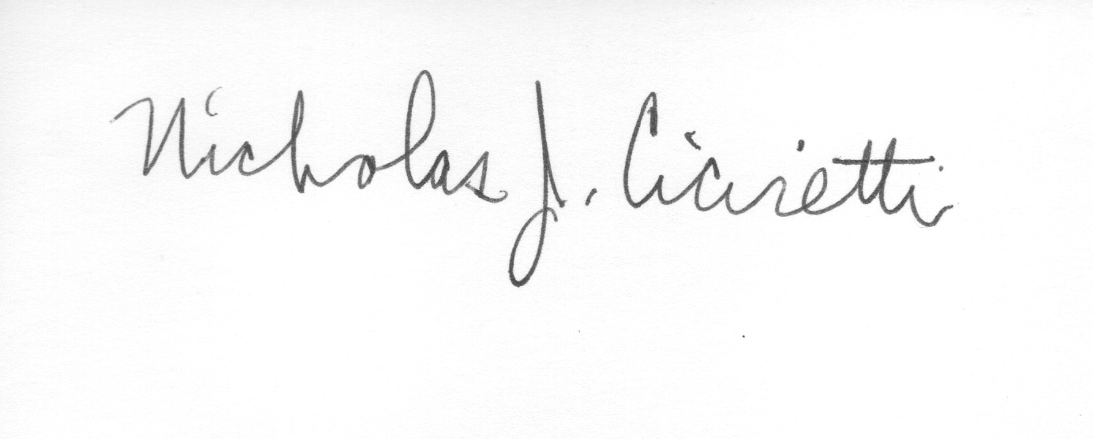
Nick Ciciretti
Secretary

