Directors Meeting Minutes
Promenade Towers
June 18, 2020

The meeting was held remotely via Zoom due to Covid-19 distancing guidelines

Directors present: Nick Ciciretti, Andy Glassberg, Judy Katzel, Megan Ladd, Mark Rockwood, Jeff von Munkwitz-Smith, and Jim Zafirson

- The meeting was called to order at approximately 7:00 PM.

- The meeting minutes from May 21, 2020 were approved as written.

- Treasurer’s Report:
  - Megan Ladd presented a summary of our income and expenses through April. The Operating account balance was $15,893 and the Reserve balance was $846,063 as of May 31, 2020.

- Unfinished Business:
- Covid-19 protocols – We have received 4 sanitizer dispensers from our cleaning company, KN Gee, which were located in the lobby, mailroom, pool, and entrance to building by the pool. There was discussion about placing some furniture in the pool area in order to allow the pool to be more readily used. It was felt that, with proper spacing and availability of disinfectant for cleaning after use, risk would be very minimal. A motion was made, seconded, and approved to place 3 tables/umbrellas with 3 chairs each, and 6 chaise lounges at the pool. Dave will send an updated notice about this to residents and owners.
- New cabinets for mail room area – Judy indicated that both cabinets are finished and will be delivered next Thursday afternoon, June 25.
- Reapplication of elastomeric coating to building exterior – Jim indicated that Knowles would be commencing the project toward the end of July. [n.b. On Friday, June 19 Jim contacted Knowles and it was decided to begin the project on building 1 on Monday, June 22.]
- Update on improvements to Sprint equipment – There has been nothing new regarding this. It was noted that T-mobile will be upgrading fiber optic cable and will be coming in next week to evaluate the current situation.
- Water shutoff access panels – There has been nothing new regarding this.
- Replacement of three air conditioning units – Mechanical Services has quoted $8000 each and may be replacing one of the units soon.
- Hot water heater shutoff recommendation and cost sharing – There has been nothing new regarding this.
- Upgrade website – Judy noted that the upgrade will be done in September.

- New Business:
- Noise incident on May 28 – There was a complaint made by a resident that, on May 28, there was excessive noise, yelling, and cursing from several individuals on the balcony of unit #114. The noise continued from approximately 7:00 until after 10:00 (the official start of “quiet” time), at which time the complainant made a video/audio recording of the incident. The complainant notified Dave DeBree the next day. Subsequent to that the Prom Towers lawyer sent a letter to the owner of unit #114, on behalf of the Association, inviting the owner to the June 18 Board meeting and stating that he may be subject to a fine and loss of privileges. The owner was at this meeting and was given 5 minutes to give his side of the story. He said he did not think the noise was excessive, it was not after 10:00, he was not contacted about any noise, and felt that any fine/loss of privileges was unfair. Following his statement, he was told that the Board would meet in executive session after the meeting to discuss and make a decision on the matter.

- Property Manager report:
  - Dave reviewed the three quotes he received for sealcoating and striping the parking areas. Following discussion, a motion was made, seconded, and approved to give the job to Shamos, at a quoted cost of $15,350. Shamos will be applying 2 coats of the material.
  - The fire pump has been serviced.
  - Dave noted that installation of ice cleats in other parking areas will be completed prior to the winter at a cost of $1300.
  - McGarvey has given a quote of $2400 to purchase and plant 8 new plants in areas around the pool which are now bare due to dead plants being removed. A motion was made, seconded, and approved to fund this project and to do so out of cash reserves.
  - Dave noted that there had been an incident of bedbugs in one of the units. Orkin came the day after Dave learned of this, and treated the affected unit. Owners of adjacent units (above, below, and on either side) were notified and given the opportunity for inspection and/or treatment. The affected unit has since been re-inspected, with no evidence of insect return, and will be re-inspected after one month. If there is evidence of insect return, the affected unit will be re-treated.

- Meeting was adjourned at 7:45 PM.

[Executive session – The noise incident was discussed and it was decided as follows: a motion was made, seconded, and approved to fine the unit owner $750, revoke common area privileges for 30 days, and place the unit owner on a probation period of 6 months which, if violated (another incident) would lead to a loss of common area privileges for an additional 6 months. It was also decided to send the video/audio file of the incident to the unit owner]

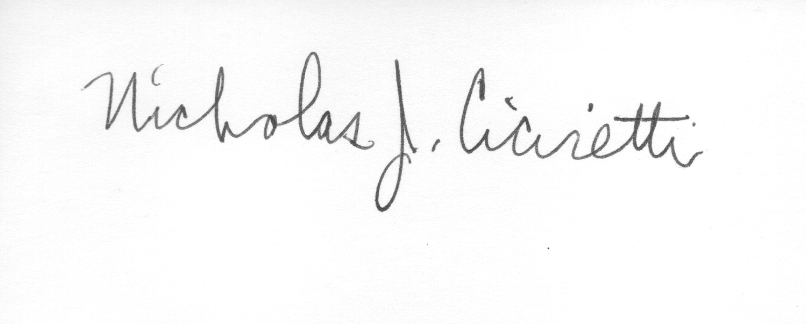
Nick Ciciretti
Secretary

