Directors Meeting Minutes
Promenade Towers
August 20, 2020

The meeting was held remotely via Zoom due to Covid-19 distancing guidelines

Directors present: Nick Ciciretti, Andy Glassberg, Judy Katzel, Megan Ladd, and Jeff von Munkwitz-Smith.

Directors absent: Mark Rockwood and Jim Zafirson.

- The meeting was called to order at approximately 7:00 PM.

- The meeting minutes from July 16, 2020 were approved as written.

- Treasurer’s Report:
  - Megan Ladd presented a summary of our income and expenses through July. The Operating account balance was $32,793 and the Reserve balance was $870,114 as of July 31, 2020.

- Unfinished Business:
- Elastomeric coating project – The project is progressing well. The Walnut St. side of building #1 is completed; the North St. side of building #2 is almost completed; ands the pool side of building #2 is ½ completed. The project is expected to extend well into September. As a result of this, the sealcoating project is on hold until completion of the elastomeric coating project.
- Covid-19 protocols – The rules regarding masks in the building, as well as the pool rules, generally are being observed. Signs will be posted at all elevators.
- Update on improvements to Sprint equipment – There has been nothing new regarding this.
- Water shutoff access panels – The panels will be ordered this week.
- Replacement of three air conditioning units – Unit #248 will not be replacing their unit. There are now four bids on replacement units ($7400, $8000-$10,000, $14,000, and $20,000).
- Hot water heater shutoff recommendation and cost sharing – There has been nothing new regarding this.

- New Business:
- Unit inspections – The 3-year cycle would normally mean inspections this fall, however, due to Covid-19, this is not desirable. A motion was made, seconded, and approved to put inspections on hold for now, and unit owners/renters will be informed that replacement batteries for entry door locks, hot water heater alarms, and smoke alarms are available at the office, along with help to replace them if necessary.
- Annual meeting arrangements – The annual meeting must be in person (not via zoom). The meeting packet has been sent out, recommending return of proxies to limit people at the meeting. The meeting will be outside, weather permitting, and will be as short as possible to conduct necessary business.
- US Cellular tower upgrade – US Cellular has 3 towers with substations and plans to upgrade them. The new units would be wider, meaning that the current cylindrical covers would not fit. The company asked whether covers would be required for the replacement units. After discussion and review of pictures, a motion was made, seconded, and approved to allow US Cellular to replace the towers and leave the use of covers (or not) to the discretion of the company.
- Grill by pool area – After discussion it was decided that unit owners will be surveyed as to their thoughts on upgrades. Judy will work on a survey.
- Policy on warnings for rule violations – There was discussion about issuing warnings vs. fines for recurring violations. It was noted that each situation is unique and that the most important thing is to be fair and consistent.
- Dave DeBree leaving R & E – Megan noted that Dave’s last day will be August 28, and officially thanked him on behalf of the board and all the residents for his dedication and tireless work in support of Prom Towers. We all wish Dave good luck.

- Property Manager report:
  - The back pool gate needs a spring.
  - The recycling dumpster has occasionally been full on the weekends due to Troiano not performing a Friday pick-up.
  - The new camera at the end of the covered parking area in the middle lot will be put in at the end of September by Digital Sky.
  - The bedbug issue has not been completely resolved. A bug was found in the middle of the room in the unit adjacent to the affected unit. Orkin will re-treat both units and conduct further inspections.
  - The pool is losing water. Christman will explore possible causes when the pool is closed in the fall.

- Meeting was adjourned at 8:20 PM.

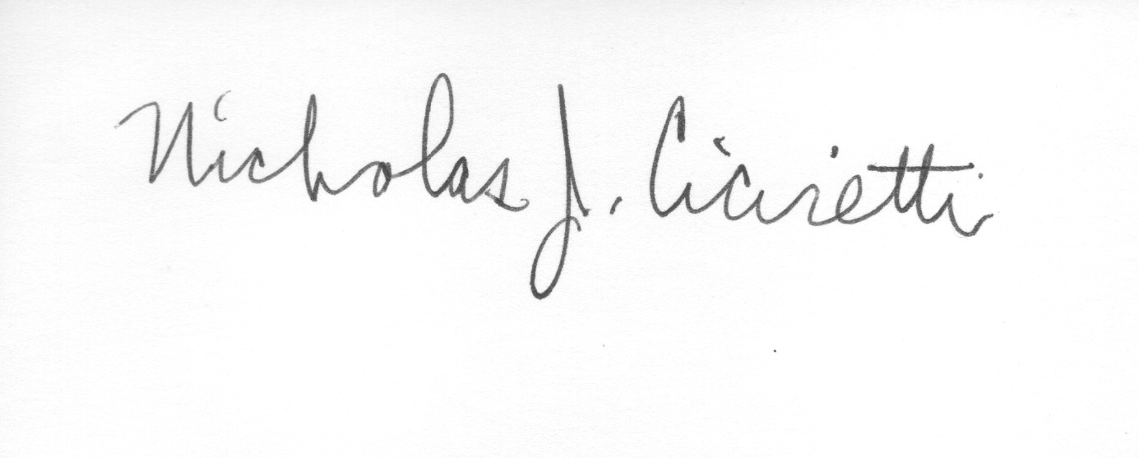
Nick Ciciretti
Secretary

