Directors Meeting Minutes
Promenade Towers
January 21, 2021

The meeting was held remotely via Zoom due to Covid-19 distancing guidelines

Directors present: Nick Ciciretti, Andy Glassberg, Judy Katzel, Mark Rockwood, Jeff von Munkwitz-Smith, Gregg Turley, and Jim Zafirson.

- The meeting was called to order at approximately 7:00 PM.

- The meeting minutes from November 19, 2020 were approved as written.

- Treasurer’s Report:
  - Jeff von Munkwitz-Smith presented a summary of our income and expenses through December. The Operating account balance was $23,856 and the Reserve balance was $724,174 as of December 31, 2020.

- Unfinished Business:
- Covid-19 protocols – Supplies for cleaning stations (wipes, sanitizer, etc.) have been obtained for the next 90 days. It was decided to have a rolling 90-day supply on hand. They are being stored in one of the closets. In a related matter, there was discussion about the request to have a chess club meet in the common room. After discussion, a motion was made, seconded, and approved to allow up to 4 people (including some who do not live in the building) to meet for the chess club. There will be a sign-in sheet in the event that tracing is needed later. And cleaning supplies will be available for the participants to clean the area before and after meeting. As elsewhere in the building, masks will be required to be worn.
- Proposal for improvements to the picnic area – Judy and Gregg presented a proposal to create a new area adjacent to the pool on the back side, which would include a new propane gas grill and would be fenced in. There was discussion about aspects of the proposal including projected costs. It was also noted that there are other expenditures which must be factored into the determination of whether the project will go forth. It was decided to table the proposal for now so as to gather additional information, particularly as it relates to propane hook-up costs for a grill, etc. The project will be revisited at the next meeting.

- New Business:
- Ongoing noise issues, including unit #144 – There have been 7 documented issues regarding unit #144 from December 12, 2020 through January 3, 2021. Six were for excessive noise and one was for creating a mess from pine needles in the hallway and elevator as a tree was removed. Although a resident of the unit did some vacuuming, additional clean-up was required by Promenade Towers cleaning personnel. One of the residents of the unit was given five minutes to address the issues and, regarding the noise issues, stated that it was due to the other resident in the unit. He also noted that he did some clean-up when told about the mess in the hallway and elevator. As per normal procedure, the board met after the meeting in executive session to discuss the incidents.
- Recycling issues – Frequently, boxes are not being broken down (i.e., flattened) prior to being placed in the recycling dumpster. This leads to the dumpster rapidly being filled, which often further leads to recyclable materials being put into the trash dumpster. After discussion a motion was made, seconded, and approved that a notice will go out to owners/residents stating that, starting in 30 days, boxes placed in the recycling dumpster without first being flattened will lead to a fine of $25 for the first offense and $100 for any subsequent offenses.
- Packages left in mailroom area – There are several residents who routinely leave numerous delivered packages in the mailroom for excessively long periods of time. There was discussion about possibly instituting rules and/or fines but no final determination was made at this time.
- Intruder in building – The person who previously entered the building and stayed overnight was recently noted trying (unsuccessfully) to enter the building. He has not been back since. The police were sent video still shots of the person but we have not gotten any information back yet from the police.
- Parking lot security – There have been several recent incidents of non-residents parking in the uncovered middle lot parking area late at night, leaving trash and having other cars coming and going, raising concerns about possible drug-related activity. There was much discussion about improving security including possible installation of additional lighting, which will be explored. In the meantime, it was decided to purchase a motion-activated game camera to obtaining pictures which could then be passed on to the police. It was also decided to contact the police coordinator stating times of activity so that the police may be more vigilant in patrolling the grounds.
- Plug for electric vehicle (space #42) – Mark presented information on possible installation of one or more electric vehicle charging stations. It was agreed by all that currently it is cost prohibitive. In a related matter, an owner had asked whether, since there is an electrical outlet near his covered parking spot, he could charge his electric vehicle there. It was pointed out that the outlet may not be active and, even if it is, it could not be used unless the outlet went directly to that unit owner’s electric meter. If the owner wishes to, he could have an electrician determine if that is the case or, if not, what would be required. Approval would have to be given by the board before any such work could be done however.
- Computer purchase/upgrade/consolidation of systems – A proposal has been submitted by Digital Sky of $8927.80 for Prom Towers to purchase a new computer and upgrade the systems to provide improved coordination between fobs, security cameras, etc. A motion was made, seconded, and approved to accept their proposal and move forward with this project.

- Property Manager report:
  - Energy loss in building stairwells – The project to insulate openings has been completed.
  - Appfolio – The new property management system at R & E is now in place.
  - Labeling of electrical panels - Brian’s plumbing has begun this project.
  - Lock-in in unit #226 – The locksmith who addressed this situation noted that this situation is very rare and having a Philips screwdriver available would allow for removal of the back plate on the lock to allow the latch to be maneuvered so as to open the door.
  - Railing on unit #228 – Tigpro should be on site soon to weld the deck railing back into place.
  - Oil stain on carpet in elevator #1 – An unsuccessful attempt was made the remove the stain. A motion was made, seconded, and approved to provide up to $1000 to replace the carpet in the elevator.
  - Fireplace – The part required has been shipped but has not arrived yet.

- Meeting was adjourned at 9:00 PM.

Executive session – An executive session was held following the meeting to discuss the noise and clean-up issues emanating from unit #144. After discussion it was decided to fine the unit owners $250 for the noise issues and $75 for the additional clean-up required.
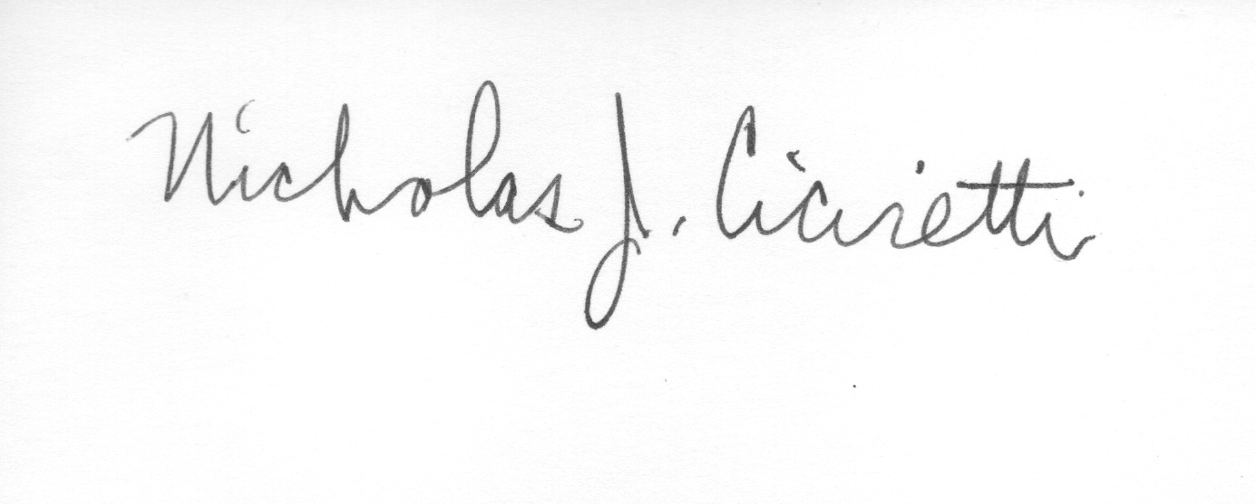
Nick Ciciretti
Secretary

