Directors Meeting Minutes
Promenade Towers
July 16, 2020

The meeting was held remotely via Zoom due to Covid-19 distancing guidelines

Directors present: Nick Ciciretti, Andy Glassberg, Judy Katzel, Megan Ladd, Mark Rockwood, Jeff von Munkwitz-Smith, and Jim Zafirson

- The meeting was called to order at approximately 7:00 PM.

- The meeting minutes from June 18, 2020 were approved as written.

- Treasurer’s Report:
  - Megan Ladd presented a summary of our income and expenses through June. The Operating account balance was $26,799 and the Reserve balance was $859,338 as of June 30, 2020.

- Unfinished Business:
- Covid-19 protocols – It was noted that most people are using masks while in the common areas of the buildings. There was discussion about modifying the pool rules to allow for a greater maximum number of people. A motion was made, seconded and approved to increase the maximum number of people in the pool area to 20, and to allow guests to use the pool. There will be some additional furniture placed in the pool area to support this change. Also, signs at building entrances will be changed to make the requirement of wearing masks while in the building more prominent, and signs will be added at the elevators on the ground and lobby levels.
- Reapplication of elastomeric coating to building exterior – The coating application has been completed on the Walnut Street side of building 1. Jim indicated that Knowles people told him that only minor caulking was necessary and that only fading was evident on the original coating, not building damage. The job will be continuing with the EFIS, then the North Street side of building 2.
- Update on improvements to Sprint equipment – There has been nothing new regarding this.
- Water shutoff access panels – There has been nothing new regarding this.
- Replacement of three air conditioning units – HVAC has provided an estimate of $7400 to replace the air conditioning unit in unit #248. This is the best estimate to-date but has not been confirmed or accepted.
- Hot water heater shutoff recommendation and cost sharing – There has been nothing new regarding this.
- Upgrade website – Judy noted that the upgrade will be done in September.

- New Business:
- Dog in building incident on June 18 – Dave DeBree noted that he received a complaint about a dog in the building. Upon examination of the video cameras it was determined that the resident of unit #144 (with guests) had a dog inside building 1. The resident was given 5 minutes to give his side of the story. Following that, a motion was made, seconded, and approved to fine the unit #144 owner $100, which is consistent with previous incidents of this nature by others.
- Grill by pool area – Judy noted that the grill is very dirty and is also very small. It was decided that she and Megan will explore possible upgrades and report back to the board.

- Property Manager report:
  - Dave noted that three decks need finishing work from last year’s resurfacing by Capozza, but that this will not be done until the elastomeric coating job is completed.
  - The seal coating will be scheduled for after the façade and EFIS parts of the elastomeric coating job are completed.
  - There are loose railings on several decks which will be secured.
  - New plantings around the pool area have been done.
  - Digital Sky will be giving a quote to add a camera at the end of the covered parking area on the building 1 side in the middle lot.
  - Additional lights will be added (motion-activated) in the covered parking area adjacent to building 1.
  - WH Demmons will work with Knowles to repair damage to the roof of the parking area in the lower lot, which was inadvertently caused by the crane being used in the elastomeric coating project.

- The board extended thanks to Judy Katzel for taking the lead on the new furniture in the mail room area which, everyone agrees, is a significant upgrade.

- Meeting was adjourned at 7:45 PM.

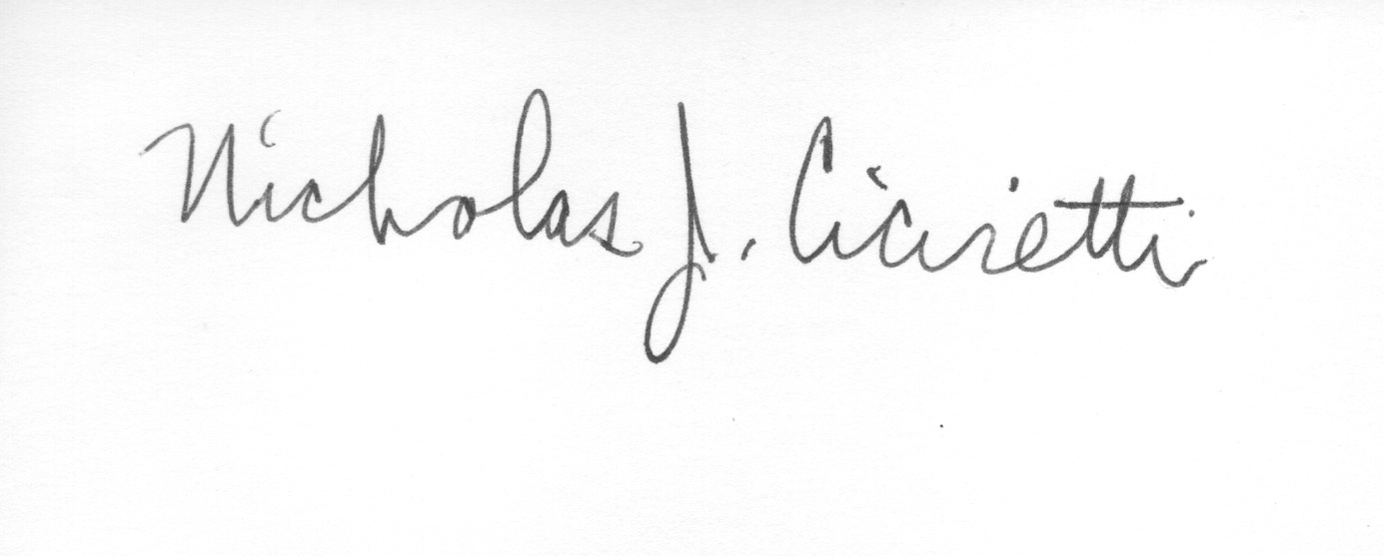
Nick Ciciretti
Secretary

