Directors Meeting Minutes
Promenade Towers
February 18, 2021

The meeting was held remotely via Zoom due to Covid-19 distancing guidelines

Directors present: Nick Ciciretti, Andy Glassberg, Judy Katzel, Jeff von Munkwitz-Smith, Gregg Turley, and Jim Zafirson.

Director absent: Mark Rockwood

- The meeting was called to order at approximately 7:00 PM.

- The meeting minutes from January 21, 2021 were approved as written.

- Treasurer’s Report:
  - Jeff von Munkwitz-Smith stated that, due to the integration of a new system, he did not have the operating fund and reserve fund amounts as of January 31, 2021. They will be forthcoming.

- Unfinished Business:
- Covid-19 protocols – Supplies for cleaning stations (wipes, sanitizer, etc.) have been obtained for the next 90 days. A question was raised about the possibility of re-opening the fitness room until the remediation necessitated by the sprinkler failure begins. R & E will determine whether there are any safety issues which make a re-opening inadvisable.
- Parking lot security – The game camera has been installed and is operating. A “see/something/say something to the police” email will be sent out to owners/residents which will include the text contact to the police. A question was raised about board member access to security cameras, but no decision was made.
- Computer purchase/upgrade/consolidation of systems - New fobs are currently being distributed and new door access panels will be installed. The possibility was raised of temporarily leaving one of the current access panels in place to allow for use of the current fobs during the switchover. It was decided to replace all the panels at the same time, then deactivate the current fobs. The issue preventing TV access to the front door camera has not been completely resolved at this time.
- Proposal for improvements to the picnic area – Judy and Gregg presented an updated proposal to create a new area adjacent to the pool on the back side, which would include a new propane gas grill, possibly a fire pit, and would be fenced in. There was significant discussion about aspects of the proposal including projected costs. It was also noted that there are other expenditures which must be factored into the determination of whether the project will go forth. Ultimately, a motion was made, seconded, but not approved to approve funds ($18,000) to begin the first phase of project. It was decided that the owners/would be surveyed regarding current use of amenities and thoughts of the advisability of the proposed upgrade. The survey will include the complete, prepared proposal, which includes projected costs. The board will meet next week to evaluate survey results and make a decision regarding the project.

- New Business:
- Frozen sprinkler pipe/water damage – Service Master Elite removed standing water, dried walls and carpets to the extent possible, and removed damaged drywall. They have provided a quote of approximately $40,000 for replacement of drywall, etc. This does not include their work already completed. A separate quote has not been received yet from an asbestos abatement company to remove asbestos discovered in the stairwell leading down to the bike room area. The Association will be responsible for the $10,000 deductible on the insurance coverage. Also, the Association may have to bear additional costs necessitated by the sprinkler damage (insulation of room where pipe froze, vents in door, alarms, etc.). These costs are not yet completely known. A motion was made, seconded, and approved for the expenditure of $2000 for work on the sprinkler system.
- No parking sign for snow removal – It was noted that, typically, the sign indicating closure of the middle parking lot in advance of snow removal has been placed by the property manager or a board member. R & E will check to see if the sign might be put out by McGarvey instead.
- Bubbling of deck surfaces – The unit #225 owner pointed out that bubbling of the deck surface following resurfacing of two years ago has not been addressed. Unit #221 has the same issue. Jim assured the owners that this will be addressed and was only on hold the past year due to the pandemic.
- McGarvey quote for work on Eastern Promenade tree area – A motion was made, seconded, and approved for expenditure of $800 to remove competing growth and trim trees on the slope.
- Dehumidifier in storage area – It was pointed out that the dehumidifier in the storage area is not operating and that the storage area is becoming very damp.
- Spectrum modem issue – An owner noted that he was told by Spectrum that he could not get an upgraded modem since it was not part of the Association/Spectrum contract. R & E will investigate this.

- Property Manager report:
  - The elevator #1 carpet (oil-stained) will be replaced.
  - The fireplace now works, using the timer in the lobby. It is no longer on a thermostat.
  - Breakers which control stairwell heaters and which had been turned off following the sprinkler failure have been turned back on.
  - The notice regarding proper recycling procedures and possible fines as of March 1 has gone out to owners.
  - Window cleaning which had not been able to take place last year following the elastomeric coating project will be done in the spring.

- Meeting was adjourned at 8:35 PM.

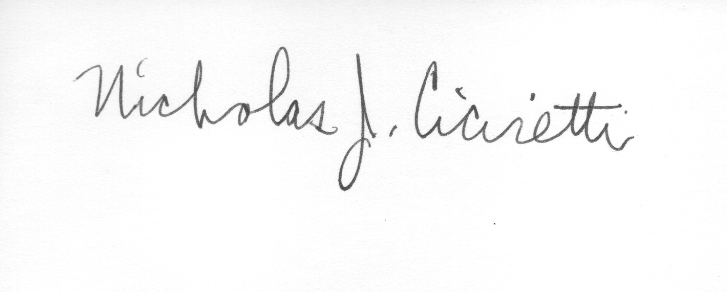
Nick Ciciretti
Secretary

Special Directors Meeting Minutes
Promenade Towers
March 1, 2021

The meeting was held remotely via Zoom due to Covid-19 distancing guidelines

Directors present: Nick Ciciretti, Andy Glassberg, Judy Katzel, Jeff von Munkwitz-Smith, Mark Rockwood, Gregg Turley, and Jim Zafirson.

- The meeting was called to order at approximately 7:00 PM.

- Jim summarized the results of the survey regarding improvements in the picnic area. A motion was made, seconded, and approved by a 6-1 vote to move forward with the proposed upgrade as per the previously discussed proposal.

- Jim noted that $2000 had previously been approved (in November 2018) for R & E to develop an operations manual for Promenade Towers. He said that additional investigation needed to be done toward this end and asked R & E to determine what additional funds are needed to move this forward.

- Meeting was adjourned at 7:20 PM.

Nick Ciciretti
Secretary

