Directors Meeting Minutes
Promenade Towers
March 17, 2021

The meeting was held remotely via Zoom due to Covid-19 distancing guidelines

Directors present: Nick Ciciretti, Andy Glassberg, Judy Katzel, Jeff von Munkwitz-Smith, Mark Rockwood, Gregg Turley, and Jim Zafirson.

- The meeting was called to order at approximately 7:00 PM.

- The meeting minutes from February 18, 2021 and the Special Board meeting from March 1 were approved as written.

- Treasurer’s Report:
  - Jeff von Munkwitz-Smith stated that, due to the integration of a new system, he did not have the operating fund and reserve fund amounts as of February 28, 2021. They will be forthcoming. A motion was made, seconded, and approved ,to accept the end-of-year-report as presented by Jeff.

- Unfinished Business:
- Covid-19 protocols – Supplies for cleaning stations (wipes, sanitizer, etc.) have been obtained for the next 90 days.
- Frozen sprinkler pipe/water damage – Repair of damaged areas (drywalling, etc.) have not been scheduled yet since the insurance adjuster and ServiceMaster have not been responding to calls made by Jeanette. Jim offered to contact the insurance adjuster to expedite the matter. Asbestos in the stairwell by the bike room has been removed. The area will be contained until results of the post-removal air testing come back positively. The library carpet will need to be replaced since the carpet cannot be restretched without tearing.
- Parking lot security – There have been no recent unauthorized visitors. Pricing for cameras in the upper lot will be coming. The trail camera has been used on an intermittent basis in the middle lot.
- Picnic area remodeling project update – Gregg, Judy, Jeff, and Jeanette met with the contractor and McGarvey to review the project. McGarvey trimmed the trees near the picnic area and removed some brush on the adjacent hillside. Mark is working on matching fabrics for the new furniture to existing furniture as closely as possible. The firepit may have to be built since the units reviewed have not been deemed acceptable. Jim discussed sizing of the firepit burner and asked for an update of firepit pricing. McGarvey also noted that there is significant erosion on the hill and that a retaining wall may be necessary in the future.

- New Business:
- Automatic water leveler for pool – Last fall Christman Pools had recommended an automatic water leveler be installed so that the pool would not have to be refilled using a hose. Projected cost was $1163. Jim noted that a pool company that he has used personally stated that there are often problems with solenoid switches failing, leading to overfilling of pools. Jim asked if Jeanette could find out from Christman about the track record of units that they have installed. Also, there is potentially a leak in the pool which has not been pinned down as yet. It was decided that, when the pool is opened in May, that it will continue to be refilled using a hose until all the questions are answered.
- Promenade Towers operations manual - $2000 had previously approved for this task. R & E recently gave a not-to-exceed figure of $2500. As a result, a motion was made, seconded, and approved, to authorize an additional $500 for the manual.
- Owner/resident and property management communication interface (Pilera/Appfolio) – There was much discussion about this. The majority of owners have not set up Appfolio accounts, even though automatic payment of monthly fees will be switched to Appfolio as of April 1. Also, R & E may eliminate Pilera (the current platform for owner/resident email) or require the Association to pay for it. Also, Appfolio does not have the same email capability as Pilera. There is much concern by the board that communication with owners/residents will take a step back, and that this is not acceptable. Jeanette will prepare and post additional information about signing up for Appfolio and will look into what Pilera might cost the Association for R & E to continue using it. It was also decided that the zoom link for the board meetings will be shared in the email that goes out with the meeting agenda.
- Electric car charging station – The owner of unit #155 has asked about having an electric car charging station installed in his covered parking spot. Mark looked into this and presented information. There is a company called Charge Point that will install a unit which the owner could use with an app. The owner is willing to pay for purchase and installation of the unit. Questions arose about how the electricity would be billed (through the Association or not). Jim noted that the building envelope cannot be breached, but Mark indicated that the company has free-standing units. It must also be determined whether the active outlet in the parking space is connected to the owner’s individual electric meter. Since there are outstanding questions to be answered, no final decision was made at this time.

- Property Manager report:
  - Fobs have been distributed.
  - T-mobile and US Cellular were recently in the building, even though they were specifically told that all upgrade work must be done from external access only.
  - Steven Schools has been contacted about hallway painting.
  - Fire extinguishers have been inspected and replaced.
  - Pine State Elevator inspected the elevators and noted that the fire alarm recall needs to be fixed prior to the state inspection.
  - Atlantic Pump inspected the water pumps and indicated that they need yearly service and that the bearings in one of the pumps need to be replaced. A quote will be coming.

- Meeting was adjourned at 8:45 PM.

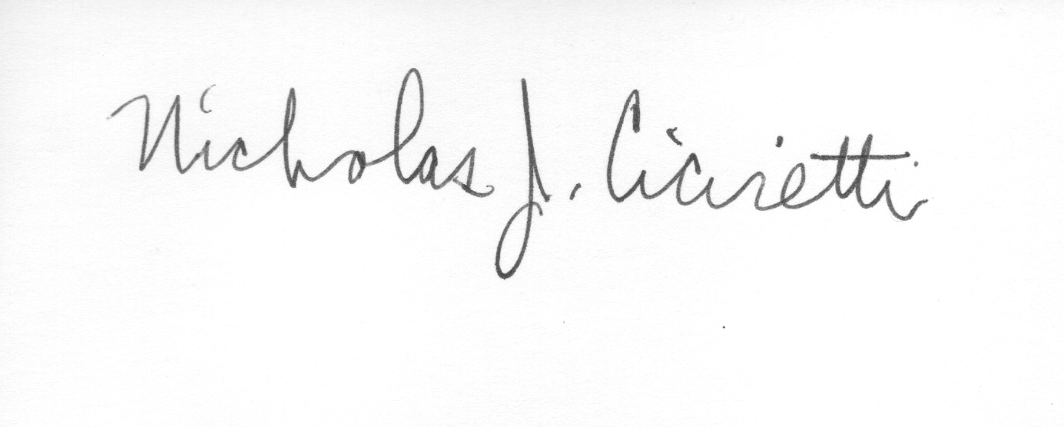
Nick Ciciretti
Secretary

