Directors Meeting Minutes
Promenade Towers
April 15, 2021

The meeting was held remotely via Zoom due to Covid-19 distancing guidelines

Directors present: Nick Ciciretti, Andy Glassberg, Judy Katzel, Jeff von Munkwitz-Smith, Mark Rockwood, Gregg Turley, and Jim Zafirson.

- The meeting was called to order at approximately 7:00 PM.

- The meeting minutes from March 17, 2021were approved as written.

- Treasurer’s Report:
  - Jeff von Munkwitz-Smith stated that, due to the integration of a new system (Appfolio), he did not have the operating fund and reserve fund amounts as of March 31, 2021. They will be forthcoming.

- Unfinished Business:
- Covid-19 protocols – Supplies for cleaning stations (wipes, sanitizer, etc.) have been obtained for the next 90 days.
- Frozen sprinkler pipe/water damage – A quote from the insurance company regarding what they will pay is forthcoming. The company (Elite) installing new drywall is scheduling 3 weeks out at this point. Paul White quoted $854 for replacement of carpet in both elevators (not a part of sprinkler damage) as part of their quote to replace the library carpet ($2900). Total Fitness will be coming in to clean and service the fitness equipment. There will be a louvered door installed on the closet where the pipe froze, and the room will be insulated and sheet rocked.
- Parking lot security – Police have been patrolling and there have been no unauthorized visitors recently. Pricing for cameras in the upper lot will be coming. We are also awaiting a quote for installation of additional lights in the middle parking lot.
- Picnic area remodeling project update – Gregg reported that JT Design plans to begin their work the end of April. He also indicated that fencing will not be available until June 28 and furniture not until July 5. Irving will be contacted about controls on propane for the grill and fire pit. A fire pit may have to be designed. Jim recommended use of brass burners rather than stainless steel. Landscaping around the area (tree trimming, etc.) has been completed.
- Automatic water leveler for pool – Christman Pools indicated that levelers work well, but need wi-fi, which is not reliably available at the pool right now. Jim and Mark discussed ways to tap in to the pool camera. Nick noted that there is wi-fi in the office which gives a weak signal at the pool. He asked if the network could be extended. Jim said he would look into that option and report back.
- Electric car charging station – Mark indicated that he contacted Brian about electrical circuit loads and has been waiting weeks for him to come out. It was decided that we would also contact Mancini Electric about providing this service as well as providing a quote for additional parking lot lights.
- Promenade Towers operations manual – Jeanette indicated that David Higham has been working on it and that a draft should be ready in a few weeks. Jim asked if R & E could give it to another of their property managers to “test drive” it when it’s ready, to see if it appears complete.

- New Business:
- Unit #157 delinquent payment status – The unit owner has, for quite a long time, been withholding the portion of monthly payments covering cable service and expects R & E or the Association to arrange cable installation with Spectrum, even though she has been told repeatedly that it is her obligation to contact Spectrum. As a result, it was decided that R & E will send a letter to the unit owner, on behalf of the Association, noting the procedure agreed upon by the Association and Spectrum and requesting payment of all monies in arrears within a 10-day period. If the monies are not paid the matter will be turned over to the Association attorney and a collection agency.
- Discussion of building custodian position – After discussion, it was decided that Jim will forward to the board a list of duties that Joe Coyne had prepared along with a list prepared by David Higham. A committee composed of Judy, Gregg, and Andy will review the information and separate the duties into two “buckets,” custodial and maintenance. The committee will then report back to the board.

- Property Manager report:
  - Fobs are still being distributed.
  - The elliptical machine is currently not working due to an electrical problem, which will be investigated.
  - T-mobile and US Cellular are working on the roof on their equipment upgrade.
  - Steven Schools has quoted $900 to remove damaged ceiling in building #2, 1st floor, and repair.
  - Pine State Elevator recently serviced the elevators.
  - The alarm company came in and will work to resolve issues regarding the display in the lobby area.
  - Atlantic Pump will service the water pumps.
  - Tigpro will be scheduled to weld the fence on the unit #228 deck.
  - We’re waiting for a quote from Mainely Reflections for window cleaning.
  - Rug cleaning will be done mid-May.
  - We’re also waiting for a quote from Brian for lighting in the middle parking lot. [As indicated earlier, Mancini Electric will also be contacted regarding this.]

- Meeting was adjourned at 8:00 PM.

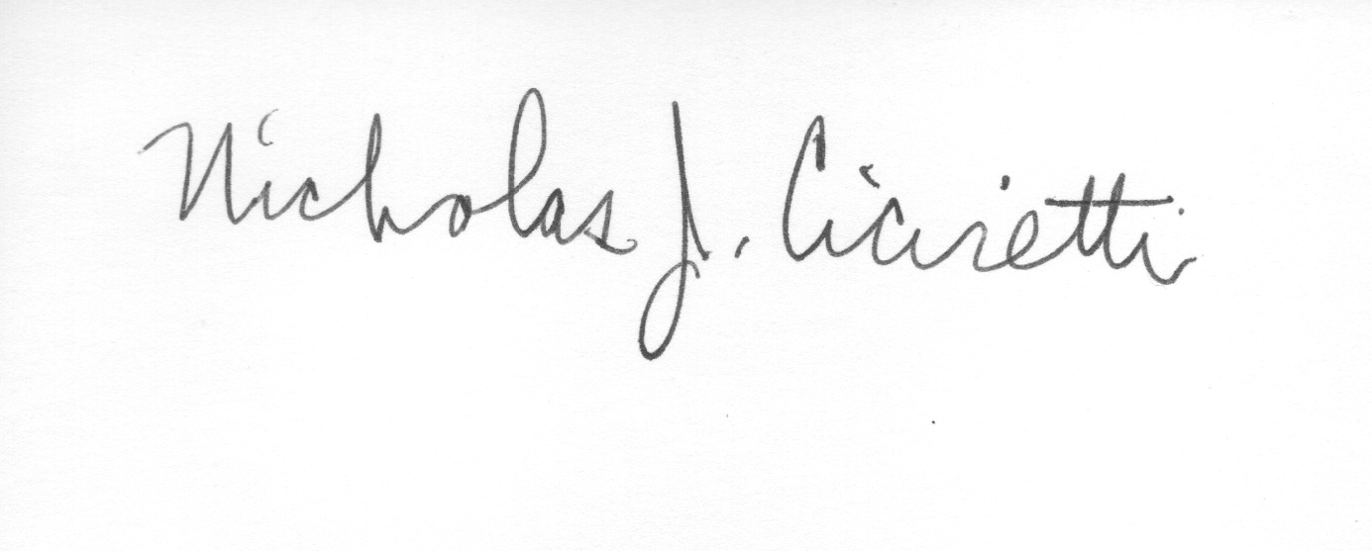
Nick Ciciretti
Secretary

