Directors Meeting Minutes
Promenade Towers
May 20, 2021

Directors present: Nick Ciciretti, Andy Glassberg, Judy Katzel, Jeff von Munkwitz-Smith, Mark Rockwood, Gregg Turley, and Jim Zafirson.

- The meeting was called to order at approximately 7:00 PM.

- The meeting minutes from April 15, 2021were approved as written.

- Treasurer’s Report:
  - Jeff von Munkwitz-Smith presented a summary of our income and expenses through April. The Operating account balance was $20,820 and the Reserve balance was $753,482 as of April 30, 2021.
  - It was decided to hold a budget workshop sometime in August. Details will be developed.

- Unfinished Business:
- Covid-19 protocols – A motion was made, seconded, and approved unanimously to follow the updated guidelines provided by Maine CDC as of Monday, May 24. That means no mask will be required in the building if fully vaccinated. New signs will be made reflecting this change. Current supplies of wipes, sanitizer, etc. will be used if use-by dates are nearing, or stockpiled otherwise.
- Frozen sprinkler pipe/water damage – A contract has been signed for restoration work. Final insurance approval is pending on certain aspects. Work should be commencing soon. Total Fitness serviced the fitness equipment.
- Parking lot security – Digital Sky quoted a price in excess of $13,000 to install two security cameras in the upper lot. Their price did not include required electrical work which would raise the total to approximately $18,000. It was decided not to pursue this further at this time.
- Picnic area remodeling project update – Gregg reported that fencing will be onsite in early July, the grill has arrived, and other work will start in early June. A motion was made, seconded, and approved by a vote of 6-1 to allocate an additional $2000 to cover additional cost for a custom-built fire pit.
- Automatic water leveler for pool – Christman Pools indicated that wi-fi is not needed, and that the control would be in the pool house. A motion was made, seconded, and approved unanimously to allocate $1500 for this installation.
- Discussion of building custodian position/current cleaning company – Our current cleaning company KN Gee has been made aware of the board’s opinion of their current work, and that we are interviewing other companies. Two other companies gave quotes of approximately $3000-$3300/month. KN Gee gave a quote of $1295/month to continue their work with an expanded scope of tasks. A motion was made, seconded, and approved unanimously to continue with KN Gee. The committee working on this (Judy, Gregg, and Andy) feel that an on-site custodian is needed, and proposed a schedule of 4 hours/day, 5 days/week. It was decided that this person should be an employee of R & E to facilitate clear reporting/supervision lines. The committee will develop a job description, then coordinate with Jeanette.
- Window washing – This is still being coordinated. Work will be done off pulleys/scaffolding from the roof, without contacting the building wall surface/coating.
- Update on electric car charging station – A new, dedicated electrical line would be needed to service charging stations that might be put in the upper lot. Re-wiring would be needed to service covered lot areas. More information is needed prior to moving forward at all on this.
- Automatic hot water heater shutoffs – Gregg provided information on the Leak Smart system, which would automatically shutoff the hot water heater supply line in the event of a leak, and provide alerts (but not shutoffs) in the event of leaks in sinks/clothes washers/bathrooms. A motion was made, seconded, and approved unanimously to purchase one Leak Smart unit to install and test. Gregg volunteered to be the test unit.
- Volunteer opportunities at Promenade Towers – Gregg coordinated information on volunteer tasks/committees. R & E will send a notice out with the list to solicit interested individuals.
- US Cellular upgrade work has been completed except for a punch list of finishing items.

- New Business:
- Security breach at poolside entrance, 5-15-21 -A visitor of the unit #126 renter propped the door open when leaving the building. Police were called and the door was re-closed. Upon their return the visitors were unable to enter the building there, but ultimately were let in through the lobby entrance. A letter to the unit #126 owner will be sent inviting him to the June board meeting to discuss this incident.
- Re-visit non-smoking initiative – This was tabled until the next meeting.
- Move in/move out policy change – After discussion, a motion was made, seconded, and approved unanimously to require a single move in/move fee for all renters, at the time of move in.
- Repainting of all hallways – It was decided to hold off repainting until September. A quote was given by Stephen Schools but was not acted on, since we will also be asking for a quote from him to repaint deck railings.

- Property Manager report:
  - Cleaning of hallway carpets will commence on June 14.
  - Both elevator carpets will be replaced next week.
  - Resurfacing of all parking lots will be scheduled.
  - There has been one fine of $25 for improperly disposing of recycled boxes (not breaking them down). This is in line with the recently implemented new policy.

- Meeting was adjourned at 8:15 PM.

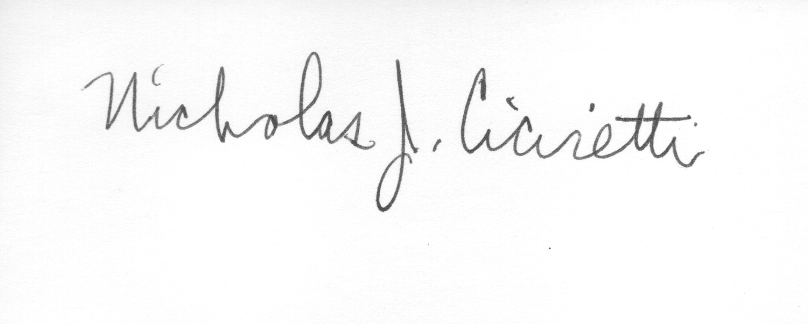
Nick Ciciretti
Secretary

