Directors Meeting Minutes
Promenade Towers
June 17, 2021

Directors present: Nick Ciciretti, Andy Glassberg, , Jeff von Munkwitz-Smith, Mark Rockwood, and Gregg Turley

Directors absent: Jim Zafirson and Judy Katzel

- The meeting was called to order at approximately 7:00 PM.

- The meeting minutes from May 20, 2021were approved as written.

- Treasurer’s Report:
  - Jeff von Munkwitz-Smith presented a summary of our income and expenses through May. The Operating account balance was $45,961 and the Reserve balance was $755,928 as of May 31, 2021.

- Unfinished Business:
- Covid-19 protocols – Our current supplies will continue to be used until they are exhausted.
- Frozen sprinkler pipe/water damage – Work should be starting the week of June 21, 2021. The work is anticipated to be completed in approximately three weeks.
- Picnic area remodeling project update – Work should be starting the week of June 21, 2021. Fencing should be installed the first week of July. Furniture should be on site the end of July. A reservation system for the grill will be set up through the Promenade Towers website.
- Electric car charging station – Mancini Electricians has given a quote of approximately $35,000 to bring in additional electrical service to the upper parking lot and install two electric car charging stations there. Due to the cost, this has been tabled. Mark will also look into the cost to wire all the covered parking spots to allow installation of individual charging stations at some point.
- Window washing – We are still waiting for a quote.
- Sealcoating of parking lots – Shamos provided an updated quote for this work. They had quoted a price of $15,350 two years ago. The board approved the funds at that time, but the job was put on hold due to Covid-19. Their updated quote is now $28,000. It was decided that we should seek additional bids.
- Volunteer opportunities at Promenade Towers – R & E sent out a notice and spreadsheet which were prepared by Gregg. The documents will also be posted on the bulletin board. Andy has agreed to be the volunteer coordinator.
- Re-visit non-smoking initiative – This was tabled until the next meeting.
- Security breach at poolside entrance, 5-15-21 – The owner was informed that a fine of $100 was being assessed for the security breach, where guests of renters in unit #126 propped open the poolside door and left the facility. The owner agreed to pay the fine. Those renters are no longer at Promenade Towers.

- New Business:
- Recruitment for the custodian position – Jeanette noted that she is still learning about the building systems and issues at Promenade Towers and that we might be better served by increasing the visits to everyday from our cleaning contractor K.N. Gee Associates personnel, since most of the duties of the custodial position are cleaning. By doing this we can avoid the complications of having a direct employee and all the related paperwork associated with their employment.
- Proposal from Spectrum for new cable/internet contract – There was discussion about proposed changes to the current Spectrum contract. It was generally agreed that the changes would be an upgrade. As a result, a motion was made, seconded, and approved unanimously to enter a new contract with Spectrum for a period of 5 years.
- Discussion on eliminating smoking on decks – We received an opinion from our lawyer that it was within the purview of the board to propose a rule change to limited common elements. After discussion, including some concern regarding such a rule change, a motion was made, seconded, and approved by a vote of 4-1 to eliminate smoking on all decks at Promenade Towers.
- Unit inspections protocol – Units were last inspected in the fall of 2017. The planned inspection for the fall of 2020 was put on hold because of Covid-19. Inspections will be done in the fall of 2021 with, at a minimum, Jeanette, Nick, and Gregg participating.
- Pool/patio rules – Gregg updated pool rules to include the planned patio/grill area. A motion was made, seconded, and approved unanimously to accept the rule changes. Laminated signs with the rules will be posted in the pool/patio area and the rules and regulations will be updated to reflect the changes. One point of emphasis will be that tables/lounge chairs may not be “reserved” by placing towels, etc. on them Also, the new fencing and current fencing will have plates of some sort installed to prevent anyone from reaching through the fence from the outside and entering without the use of a fob.
- Water pumps – A motion was made, seconded, and approved unanimously to approve $4992 for installation of new controllers and timers non the two water pumps.
- Underlayment for flooring – Paul White indicated that the soundproofing underlayment currently recommended in the rules and regulations is no longer available. There is a different product (Genie mat RST sound control underlayment) which is rubber-based and meets our requirements. A motion was made, seconded, and approved unanimously to allow its use and to update the rules and regulations to reflect that, pending approval by Jim Zafirson, who could not be at the meeting.
- Summer party – The summer party will be held from 6:00-8:00 on Wednesday, July 21.
- Door codes on closets will be changed and the board will receive the new codes.

- Property Manager report:
  - The pool may need to be resurfaced at the end of the season.
  - KN Gee will be assigning a new person to handle cleaning.

- Meeting was adjourned at 8:25 PM.

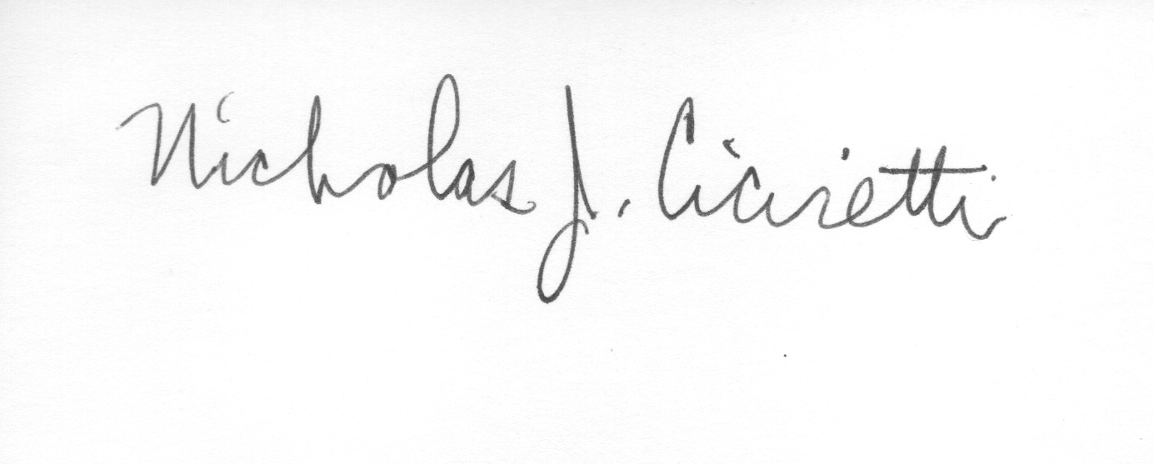
Nick Ciciretti
Secretary

