Directors Meeting Minutes
Promenade Towers
July 15, 2021

Directors present: Jim Zafirson, Nick Ciciretti, Andy Glassberg, , Jeff von Munkwitz-Smith, Mark Rockwood, Judy Katzel, and Gregg Turley

- The meeting was called to order at approximately 7:00 PM.

- The meeting minutes from June 17, 2021were approved as written.

- Treasurer’s Report:
  - Jeff von Munkwitz-Smith presented a summary of our income and expenses through June. The Operating account balance was $35,562 and the Reserve balance was $764,661 as of June 30, 2021.

- Unfinished Business:
- Frozen sprinkler pipe/water damage – There are new stains on the walls of the community room which need to be addressed. Work is proceeding, but has temporarily been put on hold to determine the cause of the stains.
- Picnic area remodeling project update – The stone patio has been put in place. The bench will be built; fencing will be installed next week; the grill will be built this weekend; Irving will turn on the propane; the fire pit will be coming in August; the furniture will be coming in early August; landscaping repair will follow at the end of the project. $36,000 has been spent so far, but this does not include the gate lock or the concrete for the grill.
- Volunteer opportunities at Promenade Towers – There have been 15 responses from “new” volunteers. There will be coordination upcoming with current volunteers.
- Re-visit non-smoking initiative – There will be a survey prepared and sent to owners gauging their interest in pursuing this at the upcoming annual meeting.
- Update on Leak Smart system – Gregg installed the system and shared his experience with it. There were questions asked regarding installation and reliability. No decision was made at this time regarding recommendation of the system.

- New Business:
- Rules and regulations re: elevators – There have been instances recently of the elevators being used for move ins/move outs/deliveries without the property manager being notified and, because of this, without pads being put in place. As a result, there has been minor damage to elevator walls. A notice will be sent out reminding owners/residents of the elevator rules, noting that cameras can be used to identify violators.
- Flashing on extension at unit #258 – Mark indicated that he noticed flashing missing on the extension next to unit #258. He will show it to Jim to make a determination as to required steps to address it.
- Building health/safety – In light of the devastating collapse of the condo in Miami, there was a question about the health and safety of Promenade Towers, asked by an owner. Jim took the time to answer the question, going back to before the major renovation, all the steps that were taken for that project, and up to the current elastomeric recoating. He noted that the building is in very good shape and was inspected about three years ago. At that time, there were minor areas noted which needed some work and were taken care of in a reasonable amount of time.

- Property Manager report:
  - Work is being done to repair coating around the new fob readers.
  - Steve Schools will prepare a quote to paint deck railings.
  - Tigpro has still not scheduled repair of the railing on unit #228. Coordination is between Tigpro and the unit renter.
  - A new water line will be installed in advance of installation of the automatic pool leveler.
  - There is no timeline yet on window washing.
  - Hayes Pump Service will be doing maintenance of the water pumps once the new controllers are installed.
  - Shamos has not given a quote yet for crack sealing in the driveways.
  - The new contract with Spectrum has been forwarded to Jim for his review and signature.
  - Digital Sky installed a new camera feed for the lobby camera which allows viewing through cable channel 1390.
  - New signs have been placed on all water closet doors.
  - There is a leak (sound of water dripping in walls) in units #117 and #127. The plumber will turn off the water in that stack tomorrow and investigate. [see note below]
  - Cummins did yearly maintenance on the fire pump. Some seals are leaking and would necessitate spending $20,000-$25,000 to replace the seals. Replacement of the fire pump will be investigated.
  - McGarvey is currently working without a contract. A new contract will be prepared.
  - Work is starting on the 2022 budget. Jeanette and Jeff will work together on this.
  - Colonial Tree did an inspection of trees on the property. A report is pending.
  - Christman Pools will prepare a quote to resurface the pool.

- Meeting was adjourned at 8:05 PM.

n.b. The day after the meeting (Friday), the plumber determined that the water leak was caused by a crack in a 4-inch drain pipe in the wall of unit #137. Repairs were made; remediation and repairs to follow.

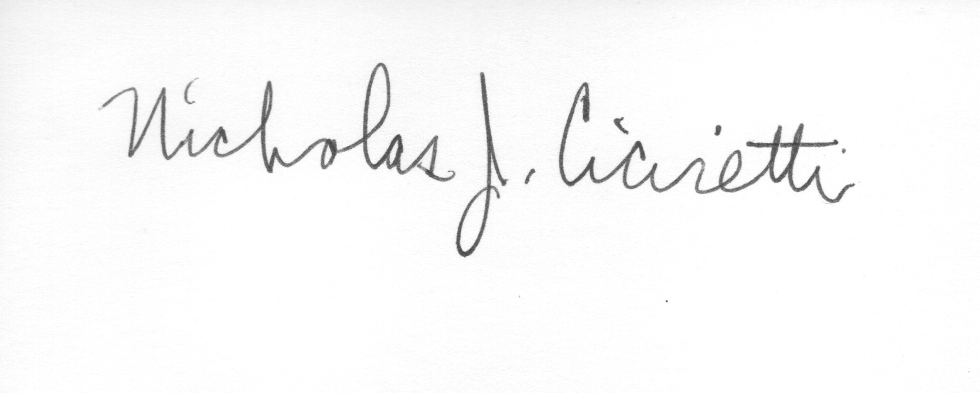
Nick Ciciretti
Secretary

