Directors Meeting Minutes
Promenade Towers
August 19, 2021

Directors present: Jim Zafirson, Nick Ciciretti, Andy Glassberg, , Jeff von Munkwitz-Smith, Judy Katzel, and Gregg Turley

Director absent: Mark Rockwood

- The meeting was called to order at approximately 7:00 PM.

- The meeting minutes from July 15, 2021were approved as written.

- Treasurer’s Report:
  - Jeff von Munkwitz-Smith presented a summary of our income and expenses through July. The Operating account balance was $15,068 and the Reserve balance was $764,117 as of July 31, 2021. He asked for authorization to make a loan of up to $25,000 from the reserve fund to the operating fund to address temporary cashflow issues. A motion to that effect was made, seconded, and approved unanimously.

- Unfinished Business:
- Frozen sprinkler pipe/water damage – New carpet will be installed in the library next week. Remediation work is almost finished.
- Picnic area remodeling project update – The grill has been installed but the timer is not working. A replacement timer has been sent. The fire table is onsite and is scheduled for installation next week. There will not be a fob pad for entrance directly into the patio. Access will only be through the pool area. Gregg will obtain pricing for two motion detector lights for the patio area. Chairs are onsite, tables will be here by the end of August, umbrellas by September 15.

- New Business:
- Tree trimming – A motion was made, seconded, and approved unanimously to approve $2389 for Colonial Tree to do extensive tree trimming on the grounds.
- Addressing erosion at the back end of the pool – It was determined that rip-rap should be put down at the back end of the patio when the ground has frozen, in order to prevent erosion. There was also some discussion about erosion along the hillside on Eastern Promenade near the back end of the pool. It was noted that the City of Portland would have to be involved in some way once property lines have been determined. Also, there is erosion at the end of the middle lot which will be addressed once the ground has frozen.
- Pool intruder on 8-2-21 – Installation of motion sensor lights and security enhancements on the entrance gates should reduce the likelihood of future occurrences.
- Pool resurfacing – It is unnecessary at the present time.
- Sealcoating of parking lots - A motion was made, seconded, and approved unanimously to approve $18,080 for All-Pro to sealcoat all parking lots in the fall.
- Mid-month decision on sewer pipe remediation – There had been a mid-month vote to approve $10,643.46 for remediation necessitated by the cracked sewer pipe. The scope of work has expanded leading to a new quote. On that basis, a motion was made, seconded, and approved unanimously to approve a new total of up to an additional $15,000 for the remainder of the work.
- Remodeling policies – Jim noted that there is a need to expand and tighten up procedures for remodeling projects due to work done which does not meet acceptable standards. Some changes he proposed include: construction permits, work done by licensed contractors, and pre- and post-work inspections by a licensed building inspector. He has spoken with the Association lawyer about this. A set of guidelines will be developed. Gregg noted that he has prepared a document addressing some of these items, which he will forward to Jim.
- McGarvey contract - A motion was made, seconded, and approved unanimously to approve a new 3-year contract with John McGarvey for grounds work and snow removal. The costs will be, $39,220 (1st year), $40,004 (2nd year), and $40,804 (3rd year).
- The budget workshop is scheduled for 8-26 at 7:00.

- Property Manager report:
  - Steve Schools will be doing hallway repainting in September as well as painting around the new fob readers. He will also provide a quote to repaint deck railings. They will need to be cleaned first. Jim reminded Jeanette that cleaning and repainting must not damage the elastomeric coating.
  - Tigpro has still not scheduled repair of the railing on unit #228. Jeanette will look for a new welder.
  - The automatic pool leveler is on order.
  - There is no timeline yet on window washing.
  - One of the new controllers for the water pumps has been installed, but the other pump has a frozen valve which must be addressed first.

- Meeting was adjourned at 7:55 PM.

n.b. On Friday it was noted that there is damage to the fire table which must be addressed.

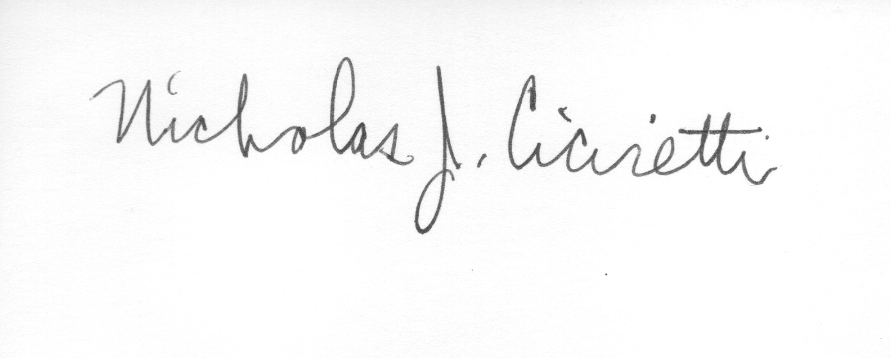
Nick Ciciretti
Secretary

