Promenade East Condominium Association
dba Promenade Towers
Annual Meeting
September 8, 2021

Directors Present: Jim Zafirson, Nick Ciciretti, Andy Glassberg, Judy Katzel, Mark Rockwood, Gregg Turley, and Jeff von Munkwitz-Smith

- The meeting was called to order at approximately 7:00 PM in the community room by President Jim Zafirson.

- Roll call was taken with the following results: There were a total of 51 (out of 80) owners either in person (21) or represented by proxy (30). These 51 represented 64.82 percent of ownership interest.

- Proof of Notice: Nick Ciciretti presented Proof of Notice.

- Minutes of the September 9, 2020 Annual Association Meeting were approved as written.

- President’s Report: Mr. Zafirson made note of the unexpected difficulties faced this year, including the sprinkler pipe in the community room closet bursting, the significant damage it caused, and the remediation required which is now almost complete. He also noted the cracked sewer pipe, which caused damage to several units, requiring additional repairs and expenses by the association. On the other hand, Mr. Zafirson pointed out improvements made to the property, including the new patio/grill/fire pit area. Finally, on behalf of the board and the Association, he thanked Mark Rockwood, who is retiring from the board, for his many years of dedicated service.

- Treasurer’s Report: Mr. von Munkwitz-Smith reported the following –

- The Operating account balance is $13,464 and the Reserve account balance is $778,570 as of August 31, 2021.

- The monthly Spectrum fee will be reduced from $50.67 to $45.47 in 2022.

- Unfinished business:

- None.

- New business:

- IRS 70-604 Election for 2021. As explained by Mr. von Munkwitz-Smith, this is an annual election by the membership. He made a motion that any excess of membership income over membership expenses, for the tax year ending December 31, 2021, shall be applied against the subsequent tax year member assessments, as provided by IRS Revenue Ruling 70-604. The motion was seconded and approved by the members. Documentation is attached.

- Election of Board of Directors members. There were three open positions for the Board. The following individuals were nominated for these positions:

  - Jeff von Munkwitz-Smith
  - Jim Zafirson
  - Jim Gwilym
  - Tracy Payne

Mr. Zafirson invited each of the above to briefly introduce themselves. Ballots were distributed to owners present. The three people elected to the board by the members were:

  - Jeff von Munkwitz-Smith
  - Jim Zafirson
  - Jim Gwilym

The current Board members, listed by term expiration, are as follows -

Term Expires
Judy Katzel 2022
Gregg Turley 2022
Nick Ciciretti, Secretary 2023
Andy Glassberg 2023
Jeff von Munkwitz-Smith 2024
Jim Zafirson, President 2024
Jim Gwilym 2024

- There was a question about the status of hot water heater replacements in light of the potential for significant damage from a catastrophic failure. Mr. Zafirson reviewed the policy requiring a certain type of hot water heater and the requirement for each heater to have an automatic feed water shutoff. He also pointed out that there is a spreadsheet containing hot water heater information for all units, which is used to monitor replacement of units which have reached their recommended useful life.

- The meeting was adjourned at approximately 8:05 PM.

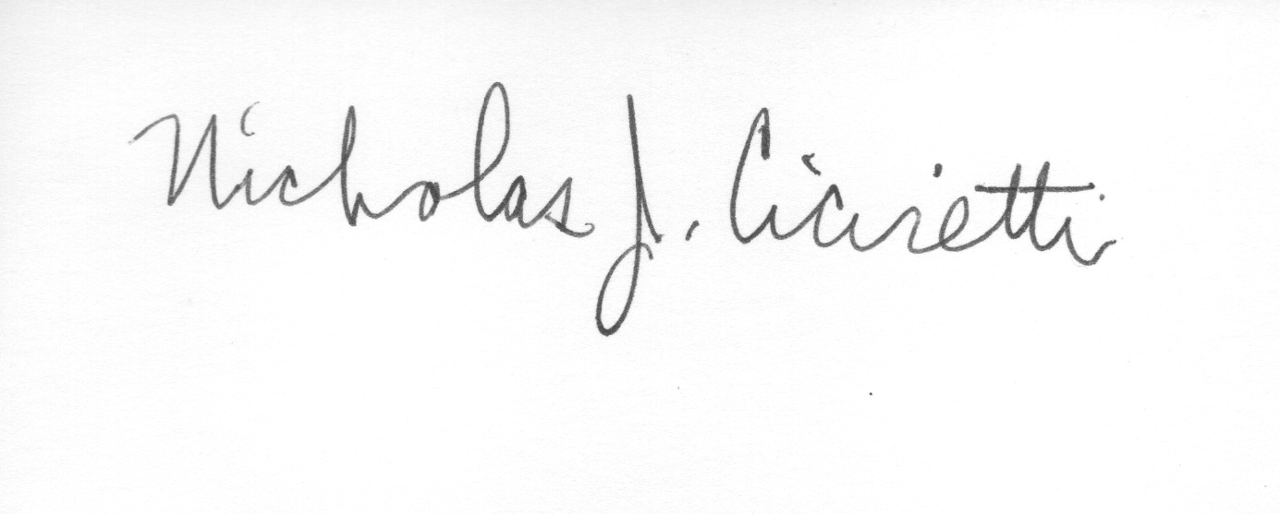
Nick Ciciretti
Secretary

Attachments: Resolution – IRS Ruling 70-604 Election

Directors Meeting
Election of Officers

A brief Directors Meeting was held immediately after the Annual Meeting at 8:05 PM in the community room. The following officers were elected for the coming year:

Jim Zafirson, President
Jeff von Munkwitz-Smith, Treasurer
Nick Ciciretti, Secretary

The meeting was adjourned at 8:45 PM.

Nick Ciciretti
Secretary

