Directors Meeting Minutes
Promenade Towers
October 21, 2021

Directors present: Jim Zafirson, Nick Ciciretti, Andy Glassberg, , Jeff von Munkwitz-Smith, Judy Katzel, Gregg Turley, and Jim Gwilym

- The meeting was called to order at approximately 7:00 PM.

- The meeting minutes from August 19, 2021were approved as written.

- Treasurer’s Report:
  - Jeff von Munkwitz-Smith presented a summary of our income and expenses through September. The Operating account balance was $24,200 and the Reserve balance was $781,332 as of September 30, 2021.

- Unfinished Business:
- Frozen sprinkler pipe/water damage – The community room ceiling has been finished and the sprinkler heads reinstalled. The carpet will be washed soon.
- Picnic area remodeling project update – The replacement for the damaged fire pit has been received and will be hooked up on November 5. We have received the covers for the grill and fire pit. There has not, as yet, been a closing date determined for the grill and fire pit. There was some discussion about changing the fencing configuration and locating the fob closer on the door which leads directly to the patio area from the lawn. However, no conclusion was reached at this time. Umbrellas have not been delivered as yet.
- Sealcoating of parking lots – Sealcoating has been completed. The second handicapped parking spot at the main entrance and the limited parking area by the mail room entrance still need painting of lines.
- Remodeling policies – This is on hold pending reassessment of our current lawyer.
- Addressing erosion at the back end of the pool – McGarvey will be delivering a load of rip-rap and working on the project.
- Tree trimming – This will take place after the ground becomes frozen.

- New Business:
- Budget for 2022 – Jeff presented the budget for 2022. There will be a 3% increase in monthly fees. This will partially be offset by a reduction in monthly fees charged by Spectrum. Gregg noted that there seemed to be an error in the Accounting/Tax Preparation expense line. It was determined that the dollar figure was actually for the Insurance line, which had inadvertently been left off. Jeff corrected those items and made a motion, which was seconded, to approve the budget, with those changes. The budget was approved by a 6-1 margin. The budget will be disseminated to all owners and, unless rejected by 2/3 of ownership at the November meeting, automatically accepted. A copy is attached to the minutes.
- Change to schedule for accepting deliveries – Deliveries are now allowed Monday-Friday. With the manager’s approval, deliveries can also be made on Saturday. Gregg proposed extending the schedule to Saturday as a policy, to accommodate people who may work, etc. Several board members opposed having the elevator pads always up on the weekends. It was also noted that, since there is already a provision for exceptions, with the manager’s approval, there is no need to formally add Saturdays as a matter of policy. It was decided to keep the policy as is.
- Combining November/December Board meetings – It was decided to combine the meetings. The meeting will be on November 18.
- Reevaluation of our current attorney – Jim Zafirson noted that our attorney of long standing has retired and that his replacement has been very unresponsive and has repeatedly made promises which he did not keep. Jim has contacted Jensen Baird lawyer Charlie Katz (a condominium specialist) about the possibility of replacing our current attorney. Jim is awaiting background information and a fee schedule.
- Unit #225 deck – Capozza had resurfaced the deck. However, there has been an ongoing leak issue, in part because of the way the deck pitches back toward the unit. Knowles will be reviewing that deck situation, as well as other decks with the same potential issue.

- Property Manager report:
  - The current property manager’s report is attached.

- Meeting was adjourned at 8:00 PM.

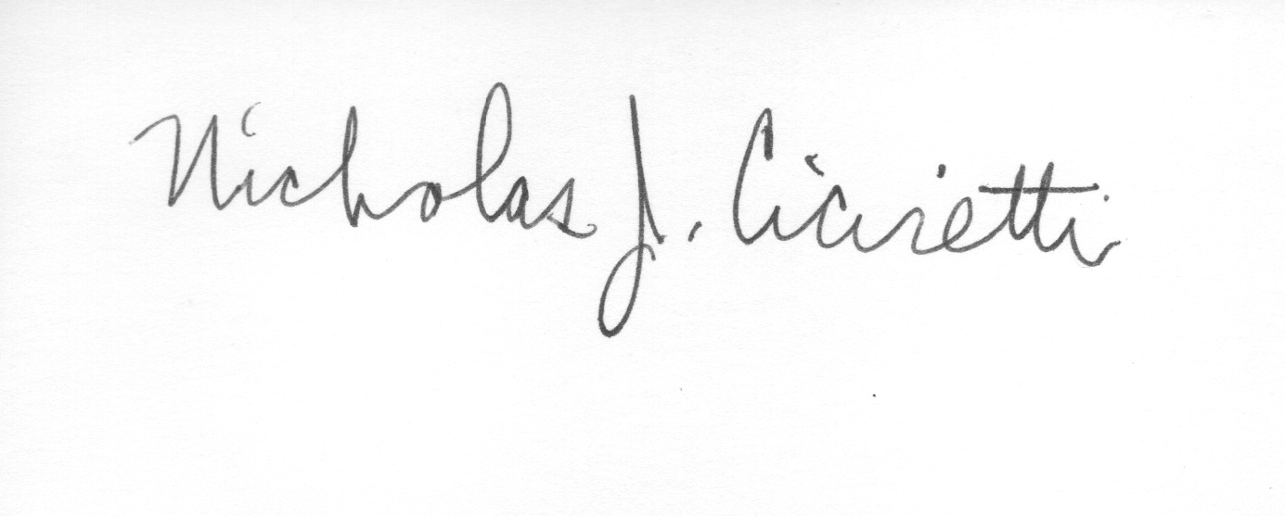
Nick Ciciretti
Secretary

Attachments: 2022 Budget
Property Manager’s Report

