Directors Meeting Minutes
Promenade Towers
January 20, 2022

Directors present: Jim Zafirson, Nick Ciciretti, Andy Glassberg, Jeff von Munkwitz-Smith, Judy Katzel, Gregg Turley, and Jim Gwilym

- The meeting was called to order at approximately 7:00 PM.

- The meeting minutes from December 16, 2021were approved as written.

- Treasurer’s Report:
  - Jeff von Munkwitz-Smith presented a summary of our income and expenses through December. The Operating account balance was $32,220 and the Reserve balance was $741,508 as of December 31, 2021. He also reported an end-of-year surplus of $672, which has been rolled into the reserve balance.

- Unfinished Business:
- Frozen sprinkler pipe/water damage – All work has been completed. We have received a check for $16,675.86, covering depreciation. An additional check should be forthcoming, with the exact amount unknown at this time.
- Remodeling policies – There is no new information at this time.
- Policy on fines – Judy and Jim Gwilym are working on this. Judy reported that they are looking at two separate categories which may warrant fines, those for which the party potentially fined may appear before the board, and those which are essentially “automatic” (i.e., no board involvement). Further reports will follow as their work proceeds.
- Addressing erosion at the Eastern Promenade side of the pool – Andy reported that he has made contact with a City of Portland official who will come to Prom Towers in the spring to determine what needs to be done, and by whom.

- New Business:
- Snow removal on decks – Nick read the current policy from the Rules and Regulations (Section 1.2 Snow Storm Procedures). There was discussion, and general agreement, that the current policy is somewhat ambiguous and needs to be more clearly and completely stated. Rooftop (5th floor) decks are exempt since snow cannot be thrown down onto areas where people walk and/or drive for obvious safety reasons. Jim Zafirson explained the rationale for the requirement to remove snow (excess weight on decks/possible structural damage, formation of ice dams, meltwater leaking into units). Gregg reviewed several points/questions which he had previously summarized in an email to the board. After discussion it was decided that the entire deck should be shoveled when snow accumulates 3” or more anywhere on the deck, within 48 hours of the end of the storm, and that calcium chloride should be used to melt accumulations of ice. Further, if the owner cannot do the removal, arrangements can be made for R & E personnel to do it, at a cost to the owner. Gregg will take all the information and codify it in a clarified rule, which the board will then vote on.

- Property Manager report:
  - Jeanette Haskell reported on the following items from the report that she recently sent to the board:
  - Painting – Steve Schools has essentially completed painting on all floors, the mailroom, and the lobby.
  - Spectrum upgrade – Spectrum has completed all rewiring. There was a part they were waiting for to complete the switchover. The part has come in and the switchover should be completed on January 25.
  - Work on trees – Colonial Tree should be doing the work mid/end of February.
  - Leak into unit #214 – This is still being investigated.
  - Computer upgrade – A new computer will be obtained for the office, but the software upgrade must allow the door/phone program to be migrated over.
  - Natural gas/propane detectors – Three detectors have been ordered for the lobby, as required by regulation.
  - There were four fines of $25 for not properly breaking down cardboard boxes placed in recycling.

- Meeting was adjourned at 7:40 PM.

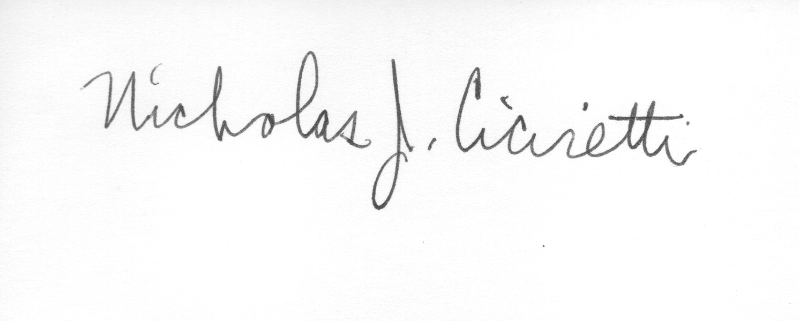
Nick Ciciretti
Secretary

Attachments: Property Manager’s Report

