Directors Meeting Minutes
Promenade Towers
December 16, 2021

Directors present: Jim Zafirson, Nick Ciciretti, Andy Glassberg, Jeff von Munkwitz-Smith, Judy Katzel, Gregg Turley, and Jim Gwilym

- The meeting was called to order at approximately 7:00 PM.

- The meeting minutes from October 21, 2021were approved as written.

- Treasurer’s Report:
  - Jeff von Munkwitz-Smith presented a summary of our income and expenses through November. The Operating account balance was $25,089 and the Reserve balance was $750,375 as of November 30, 2021.

- Unfinished Business:
- Frozen sprinkler pipe/water damage – All work has been completed.
- Picnic area remodeling project update – The fire pit must be secured to the deck. That work, along with the propane hook-up, will be completed in the spring. Covers are now in place for winter protection on both the grill (canvas cover) and fire pit (stainless steel cover). Burns fencing has quoted a price of $1895 to change the 6-foot fence to a 4-foot fence between the pool and patio areas. After some discussion it was decided that additional cost information is needed for other parts of the fence reconfiguration.
- Remodeling policies – The Association’s new lawyer will be working on correlating/confirming what the Association may do viz-a-viz remodeling. It was noted that, although we do not wish to or need to be involved in minutiae of renovations, there are some important considerations and requirements that must be met. A motion was made, seconded, and approved unanimously that owners must submit a renovation plan to Jeanette, which would then be forwarded to the board. Details will need to be developed once we hear back from our lawyer.
- Addressing erosion at the Eastern Promenade side of the pool – Erosion has not significantly advanced in the last several years. Andy will work with the city to determine what we can/cannot do and what the city may be doing as well.
- Reevaluation of our current attorney – The Association will be using an attorney from Kelly, Remmel, and Zimmerman.
- Budget for 2022 – The budget was ratified by the board at the October, 2021 meeting. Since there was not a rejection by 2/3 of ownership at this meeting, the budget was formally adopted. Jeff noted that there were two corrections to the budget which were needed. A motion was made, seconded, and approved unanimously to correct the antenna income, adding $14,954 to the original amount, which now becomes $134,412. A motion was made, seconded, and approved unanimously to note that, since it was not realized that the new Spectrum contract with “no increase” did not include taxes and fees. Instead of a savings of $5.20 per month, owners will pay the same amount as this year.

- New Business:
- Quote on deck repairs – Coatings put in several years ago have failed on several decks. If re-sloping of those decks is needed the Association will bear the cost. However, the removal and recoating of the decks should be the responsibility of Capozza Concrete, which did the original recoating.
- Policy on fines – After some discussion it was decided that Judy and Jim Gwilym will work on a policy on fines. There was agreement that a listing of monthly fines (without unit numbers or names) should be part of the minutes.
- T-Mobile upgrade work – Jim Zafirson noted that it was not clear, based on a site visit with T-Mobile that he and Jeff were part of, exactly what work is proposed. More information is need from them.
- Solar power for building and charging stations – Gregg provided some preliminary information on a proposal to install a series of electric vehicle charging stations which would be solar powered. No action was taken at this time.

- Property Manager report:
  - The current property manager’s report is attached. There was one fine of $25 for not properly breaking down a cardboard box placed in recycling.

- Meeting was adjourned at 8:20 PM.

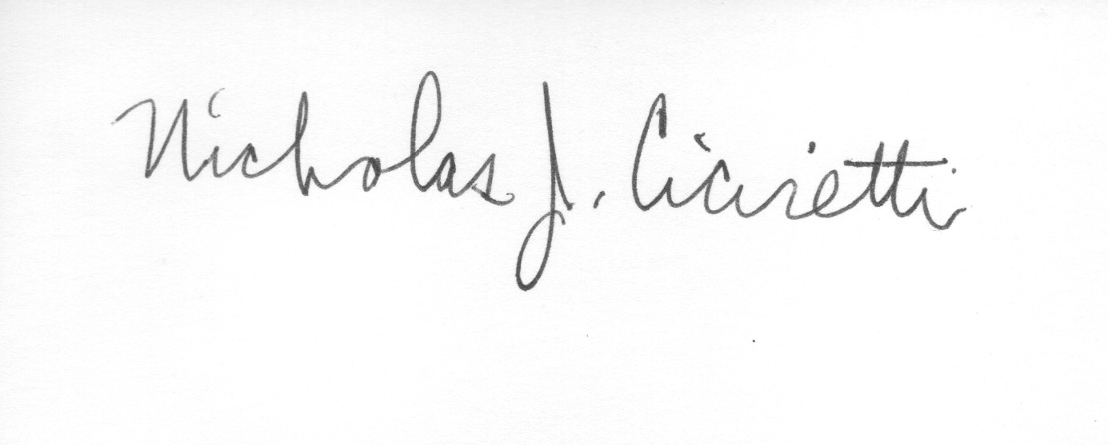
Nick Ciciretti
Secretary

Attachments: Property Manager’s Report

