Directors Meeting Minutes
Promenade Towers
February 17, 2022

Directors present: Jim Zafirson, Nick Ciciretti, Andy Glassberg, Jeff von Munkwitz-Smith, Judy Katzel, Gregg Turley, and Jim Gwilym

- The meeting was called to order at approximately 7:00 PM.

- The meeting minutes from January 20, 2022 were approved as written.

- Treasurer’s Report:
  - Jeff von Munkwitz-Smith presented a summary of our income and expenses through January. The Operating account balance was $43,374 and the Reserve balance was $742,847 as of January 31, 2022.

- Unfinished Business:
- Frozen sprinkler pipe/water damage – All work has been completed. There is still some money to be received.
- Fire safety systems – The board discussed the legal counsel’s assessment of our current system viz-a-viz the City of Portland’s requirements. The board agreed with the recommendation to maintain a reserve budget line item in case upgrades are required in the future.
- Mask policy in building – We have been following the City of Portland masking requirements. Since the City of Portland has removed the requirement to wear masks in all indoor settings, Promenade Towers will no longer require that masks be worn in the building.
- Policy on fines – Judy and Jim Gwilym are working on this. Judy reported that they are looking at two separate categories which may warrant fines, those for which the party potentially fined may appear before the board, and those which are essentially “automatic” (i.e., no board involvement). She presented possible wording on the revision. After discussion it was decided that Judy and Jim will do some revision/addition to the wording and present it to the board when it is ready.

- New Business:
- Update of Rules and Regulations – Nick reported that, since the last version of the Rules and Regulations was in 2019 and there have been several approved changes since then, he is working on an update. He, Jeff, and Jeanette developed a list of required changes. When the update is complete Nick will circulate it to the board, although a vote should not be required since all changes have previously been approved.
- Stairwell repainting – Jeanette received a quote of $31,300 from Steve Schools for top-floor-to-bottom-floor repainting of all three stairwells. This would include ceilings, walls, and stairs. No action was taken at this time since any painting would not be undertaken until after roof-top cell phone work has been completed.
- Replacement of lobby furniture – Judy, Gregg, and Mark Rockwood will be a committee tasked with looking at options for replacement of lobby furniture.
- Board code of conduct – Jeanette presented a code of conduct document for board members that she uses at her other properties. It was decided that it will be used at Promenade Towers and that all board members will be asked to sign the document and keep to the code.
- Appeal of recycling fine – An owner who had received a fine for improper recycling practices appeared and appealed the fine, stating her point of view. It was decided that the fine would stand.
- Mid-month decisions on 1) snow removal on decks and 2) renewal of R & E property management contract – Nick reported that there was a mid-month vote on a clarification of the deck snow removal policy. Two board members recused themselves; the vote on the policy clarification was 5-0. Also, there was a mid-month vote to renew the property management contract with R & E; the vote was 7-0.

- Property Manager report:
  - Jeanette Haskell reported on the following items from the report that she recently sent to the board:
  - Painting – Steve Schools has completed painting on all floors, the mailroom, and the lobby. Only two outside fob readers remain to be painted.
  - Deck repair – Knowles fixed the railing on unit #228. It will need to be redone in the spring since the actual work done was not what was requested. Knowles also did temporary repair work on the deck wall of unit #225. Final repair will be done in the spring.
  - Cleaning in the building – Jeanette met with Kevin Gee regarding additional days and work schedule.
  - Spectrum upgrade – Spectrum has completed all work. The $8000 check has been received and deposited.
  - Water pump – Hayes pump has made recommendations regarding replacement of the pump motors. There will still be an investigation into possibly replacing the entire system with a more efficient system.
  - Jeanette sent a “theft of services” letter to Gary Porter (non-resident/owner) for dumping debris in the Promenade Towers dumpster.
  - Brian (from Brian’s Electric and Plumbing) is currently working on several electrical work on the property.
  - Hall carpeting – Jeanette asked Paul White for an estimate for complete carpet replacement in the building. This would be only for capital budgeting purposes at this time. Jim asked that they also provide an estimate for replacement using carpet squares. While more expensive, this would provide an easier way to deal with stains that cannot be removed.
  - Work on trees – Colonial Tree should be doing the work mid/end of February.
  - There were four fines of $25 for not properly breaking down cardboard boxes placed in recycling.

- Meeting was adjourned at 8:15 PM.

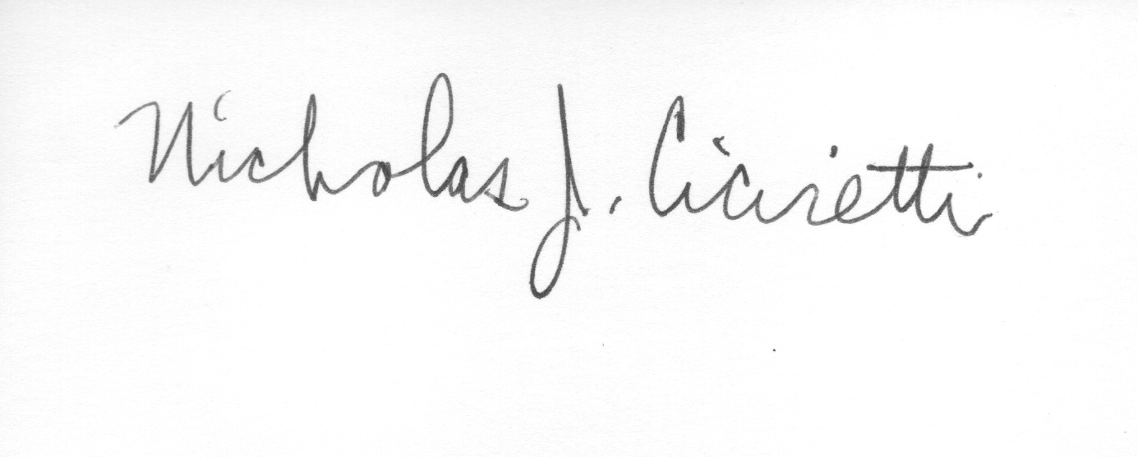
Nick Ciciretti
Secretary

