Directors Meeting Minutes
Promenade Towers
April 21, 2022

Directors present: Jeff von Munkwitz-Smith, Andy Glassberg, Judy Katzel. Jim Gwilym, Nick Ciciretti

Directors absent: Jim Zafirson, Gregg Turley

- The meeting was called to order at 7:00 PM.

- The meeting minutes from March 17, 2022 were approved as written.

- Treasurer’s Report:
  - Jeff von Munkwitz-Smith presented a summary of our income and expenses through March. The Operating account balance was $17,753 and the Reserve balance was $767,374 as of March 31, 2022.

- Unfinished Business:
- Replacement of Lobby furniture – Measurements have been taken. We should be receiving something next week from the designer for possible changes to the lobby, library, and community room.
- Update on status of Rules and Regulations 2022 – Nick reported that the update is essentially complete. The only sections not finished are the policy on fines (discussed at this meeting and outlined below) and the remodeling policies (awaiting information from our attorney). All sections changed or added will be noted as such to make it easier to compare to earlier versions. Also, an appendix has been added for additional information provided routinely by the property manager but not included elsewhere (e.g., Spectrum cable policy), and for the as-yet uncompleted remodeling policies.
- Policy on fines – There was some discussion on the policy, as prepared by Judy and Jim G. with input by Jeanette. Wording was revised regarding bringing carts through the front door. It will now say that carts belonging to Promenade Towers and routinely stored in the service entrance area must be brought in and out through the service entrance. This means that personal carts with groceries may still be brought in through the front entrance. A motion was made, seconded, and approved unanimously to accept the policy on fines with the wording change noted above.
- Re-visiting electric car charging – Mark Rockwood presented informed he received, after meeting with Laplante Electric, for work necessary to install electric car charging stations in the upper lot. There will still be input needed from CMP before any sort of proposal may be presented to the board. A motion was made, seconded, and approved unanimously to authorize Mark to spend up to $200 for a consultant to be involved when he meets with CMP.

- New Business:
- Remodel requests – A motion was made, seconded, and approved unanimously to approve remodeling plans for units #225 and #157.
- Pool furniture – After discussion about the timing for putting out the pool/patio area furniture it was decided that the furniture should not be put out until the pool opens in mid-May since the pool cover is still on and Christman Pool will need unfettered access.
- Website maintenance – Nick noted that some maintenance is needed to allow him to input minutes, etc. Judy will contact Peter Martin to make the necessary changes.
- Andy noted that the City of Portland arborist will be here on April 28 to review our site viz-a-viz property lines and responsibilities with respect to any changes to the hill on the Eastern Promenade side of the property.

- Property Manager report:
  - All three garages have been power washed.
  - The pool will be opening on May 13.
  - Colonial Tree completed the tree trimming.
  - Repainting the storage area spot and the handicapped parking spots out front will take place when the weather warms.
  - KN Gee cleaners will be onsite Monday, Tuesday, Thursday, and Friday. It was noted that the building is looking very good with the new cleaning schedule.
  - We will be receiving an additional check (amount unknown) from Hanover Insurance for work related to the recent sewer pipe leak.
  - There is a leak into #154, apparently from the deck.
  - The elevators have been inspected and successfully passed.

- Meeting was adjourned at 7:55 PM.

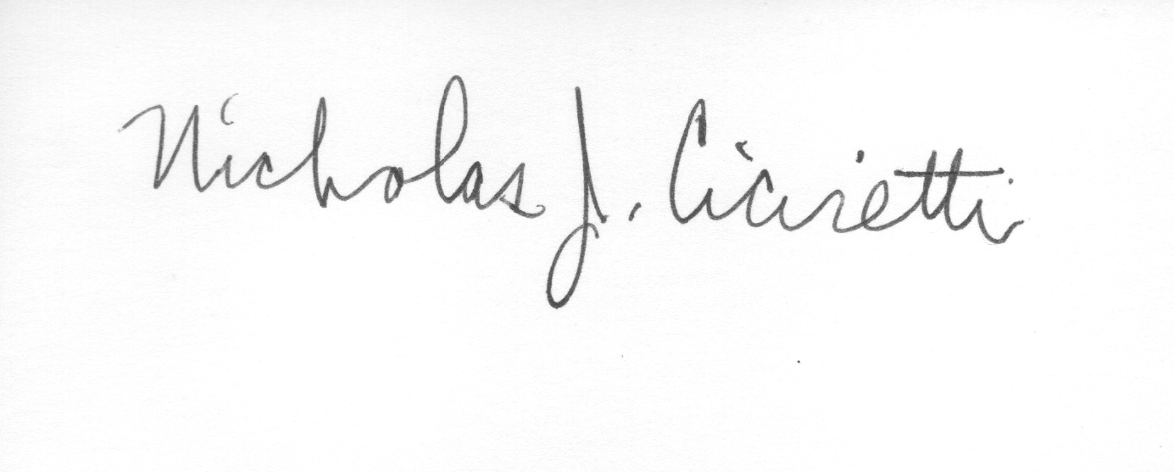

Nick Ciciretti
Secretary

