Directors Meeting Minutes
Promenade Towers
May 19, 2022

Directors present: Jeff von Munkwitz-Smith, Andy Glassberg, Judy Katzel, Gregg Turley, Jim Gwilym, Nick Ciciretti, Jeanette Haskell-Property Manager

Director absent: Jim Zafirson

- The meeting was called to order at 7:00 PM.

- The meeting minutes from April 21, 2022 were approved as written.

- Treasurer’s Report:
  - Jeff von Munkwitz-Smith presented a summary of our income and expenses through April. The Operating account balance was $11,391 and the Reserve balance was $792,636 as of April 30, 2022. The monthly financial statement was approved with a change noted by Jim Gwilym.

- Unfinished Business:
- Replacement of Lobby furniture – Judy presented drawings and a proposed budget for renovating the lobby, library, and common room. After much discussion it was decided that owners should be polled regarding lobby renovation with several options presented, as well as an option not to do a replacement at all at this time. This should be done before the board makes any vote.
- Addressing erosion at the back end of the pool – Andy reported on a meeting /site visit with the City of Portland arborist, Jeff Tarling. Promenade Towers property runs to the sidewalk. The arborist noted that several trees on the hillside are considered invasive, but that they’re not presenting any problems. He also said that there is limited erosion at the far end of the hillside and recommended additional rip-rap be placed there. He recommended Gorham Sand & Gravel.
- Deck repair – Jeanette noted that Jim Zafirson determined that the Association is responsible and would pay for repairs to the deck on unit #225 (regrading and surface repair). Knowles will do the work at a cost of approximately $5500.
- Electric car charging station – Mark Rockwood presented information after meeting with Laplante Electric and CMP for work necessary to install electric car charging stations in the upper lot. It was recommended that, if the project moves ahead, electric lines be run underground to a box on our property. Additional information will be forthcoming.

- New Business:
- Realignment of light pole(s) in pool area – Jeanette is waiting for calls back on realigning the leaning light pole. This may require removal of some plants.
- Appeal of recycling fine – The appeal of the fine was denied by the board.
- Remodel requests – A motion was made, seconded, and approved unanimously to approve remodeling plans for unit #148.
- Fire table and gas grill – The gas grill burner has been adjusted and the grill is operational. There is a part needed for the fire table. It is not yet operational.

- Property Manager report:
  - Repainting of loading area and handicapped parking spots in front will be done soon (weather permitting).
  - The pool has been opened, but the pool heater is not on yet due to required repairs. It will cost approximately $1500 for the heater repair.
  - Water pump motors will be onsite in July.
  - KN Gee’s new cleaning scheduled is working well. The building is looking good.
  - A window leak in unit #132 will be repaired on 5-26.
  - Pool lights on the right side poles are not working and will be fixed.
  - The broken window in unit #258 will be fixed soon.
  - Digital Sky fixed the pool gate, which had not been automatically closing.
  - Jeanette recommended requiring 48-hour notice to the property manager when requesting a water shutoff in one of the water stacks on the 3rd floor. A motion was made, seconded, and approved unanimously to require such notice. Nick will update the Rules and Regulations to that effect and post the updated rules and regulations on the website.

- Meeting was adjourned at 8:25 PM.

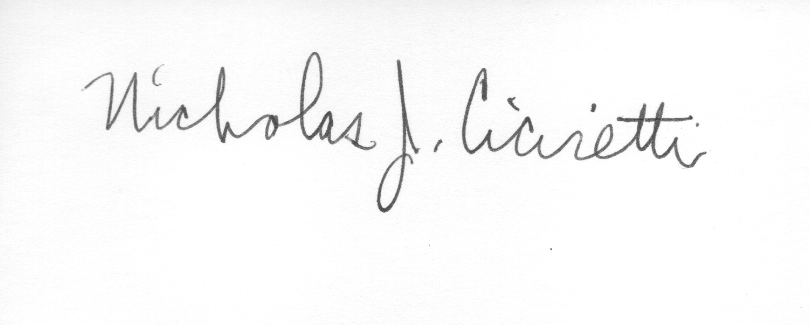

Nick Ciciretti
Secretary

