Directors Meeting Minutes
Promenade Towers
June 16, 2022

Directors present: Jim Zafirson, Jeff von Munkwitz-Smith, Judy Katzel, Gregg Turley, Jim Gwilym, Nick Ciciretti, Jeanette Haskell-Property Manager

Director absent: Andy Glassberg

- The meeting was called to order at 7:00 PM.

- The meeting minutes from May 19, 2022 were approved as written.

- Treasurer’s Report:
  - Jeff von Munkwitz-Smith presented a summary of our income and expenses through May. The Operating account balance was $26,008 and the Reserve balance was $770,064 as of May 31, 2022. The monthly financial statement was approved. A motion was made, seconded, and approved unanimously to transfer $26,105 from the reserve fund to the operating fund to cover taxes that should have been paid by the cellular tower reserve monies.

- Unfinished Business:
- Deck repair – Jeanette noted that Capozza will just repair bubbles in decks, not do resloping or repair work. Jim Z asked Jeanette to set up a 3-way phone call between him, Jeanette, and Capozza to discuss the situation. Jeanette also said that Knowles is set up to do deck repair on unit #225 in July.
- Realignment of light pole(s) in pool area – Jeanette said that a contractor indicated that the four light poles need new bases. Jim Z indicated that the original bases were not deep enough to prevent frost heaves and that deep holes with concrete could be used to anchor the existing bases. Jeanette will explore this option. She also noted that electrical wired on several of the poles need to be enclosed by conduit to protect them from exposure. This would be done later.
- Fire table and gas grill – Gregg said that the fire pit ignition system has been replaced under warranty and that both the grill and fire pit are operational.
- Electric car charging station – There was discussion on the proposal from Laplante Electric to do work necessary for installation of one or more electric car charging stations, either through overhead wiring or through underground wiring. Mark Rockwood noted that there would be no additional charges from CMP to provide electrical service, although Prom Towers would be billed for electricity usage and would then have to bill users (with an upcharge to cover some of the cost of leasing the charging station(s)). There could also be some sort of “buy-in” (monthly or annually) for owners/renters to use the station(s). These details have not been worked out as yet. It was decided to send out a survey to owners to assess interest in this project (current number of electric vehicles, future interest in purchase of an electric vehicle, willingness to cover cost of the charging station lease, etc.) Gregg prepared a draft of the survey which will be revised to reflect comments from the board.

- New Business:
- Summer party – The summer party will be on June 22.
- Trash pick-up timing – A resident indicated that, currently, trash pick-up is very early, sometimes before 6:00 am. The board agreed that this is not acceptable. Jim Z asked Jeanette to determine the increased cost of having R & E personnel move the dumpsters to allow for later pick-up.
- T-Mobile and WGME contracts – Jim Z noted that details are still being worked out with T-Mobile and that has priority before addressing WGME, which should just renew.

- Property Manager report:
  - Gorham Sand and Gravel indicated that there is quite a bit of erosion at the back end of the pool and recommended that an engineering company like S.W. Cole assess the situation to recommend remediation. Jim Z will evaluate the situation before the board meeting in July.
  - The bike room is full/overfilled with bikes and will be surveyed by Jeanette to determine if there are bikes that were left by previous owners/renters which should be removed.
  - There is an owner who has not been cooperating with remodeling rules (not completely sharing plans, not giving dates for contractors to be onsite, allowing contractors to improperly use elevators without pads on the walls, etc.). This owner has been reminded of these deficiencies many times. The owner will be receiving a letter from R & E regarding the rules and indicating that future fines may be forthcoming.
  - Cars of owners and residents need to have the PT sticker in place to readily identify them.
  - Unit #131 has to have its door lock re-keyed to the master.

- Meeting was adjourned at 8:15 PM.

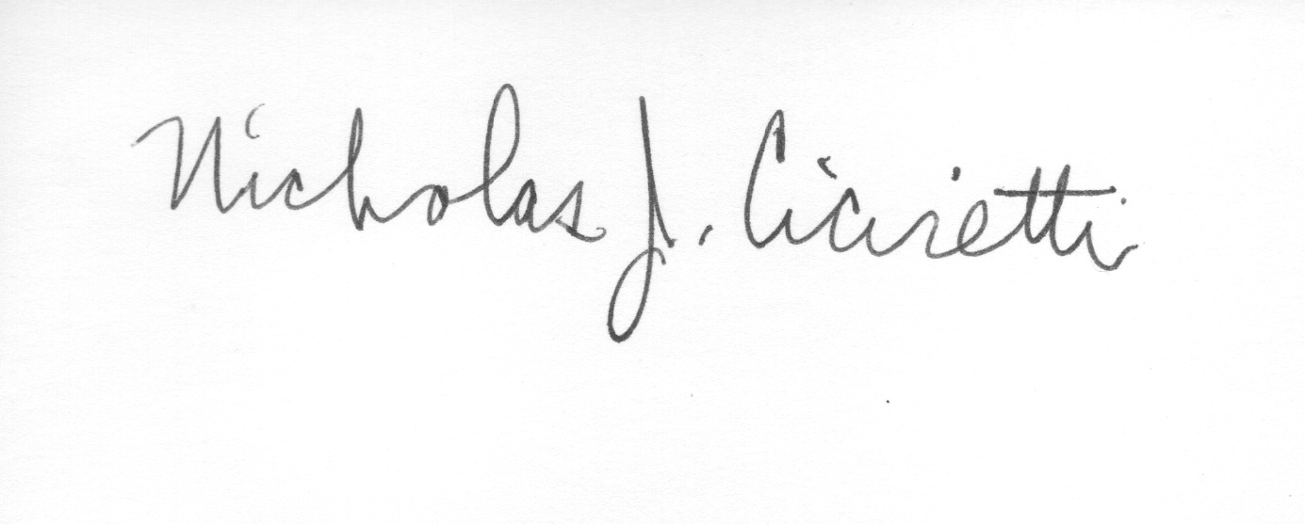

Nick Ciciretti
Secretary

