Promenade East Condominium Association
dba Promenade Towers
Annual Meeting
September 14, 2022

Directors Present: Jim Zafirson, Nick Ciciretti, Andy Glassberg, Judy Katzel, Jim Gwilym, Gregg Turley, and Jeff von Munkwitz-Smith

- The meeting was called to order at approximately 7:00 PM in the community room by President Jim Zafirson.

- Roll call was taken with the following results: There were a total of 43 (out of 80) owners either in person (20) or represented by proxy (23). These 43 represented 52.83 percent of ownership interest.

- Proof of Notice: Nick Ciciretti presented Proof of Notice.

- Minutes of the September 8, 2021 Annual Association Meeting were approved as written.

- President’s Report: Mr. Zafirson noted the investment in money and time put in by the board and the non-board owners. He also pointed out that the Association is in a very strong financial position.

- Treasurer’s Report: Mr. von Munkwitz-Smith reported the following –

- The Operating account balance is $26,978 and the Reserve account balance is $778,287 as of August 31, 2022.

- Unfinished business:

- None.

- New business:

- IRS 70-604 Election for 2022. As explained by Mr. von Munkwitz-Smith, this is an annual election by the membership. He made a motion that any excess of membership income over membership expenses, for the tax year ending December 31, 2022, shall be applied against the subsequent tax year member assessments, as provided by IRS Revenue Ruling 70-604. The motion was seconded and approved by the members. Documentation is attached.

- Election of Board of Directors members. There were two open positions for the Board. The following individuals were nominated for these positions:

  - Judy Katzel
  - Gregg Turley
  - Mark Rockwood

Mr. Zafirson invited each of the above to briefly introduce themselves. Ballots were distributed to owners present. The two people elected to the board by the members were:

  - Judy Katzel
  - Gregg Turley

The current Board members, listed by term expiration, are as follows -

Term Expires
Nick Ciciretti, Secretary 2023
Andy Glassberg 2023
Jeff von Munkwitz-Smith 2024
Jim Zafirson, President 2024
Jim Gwilym 2024
Judy Katzel 2025
Gregg Turley 2025

- The meeting was adjourned at approximately 8:00 PM.

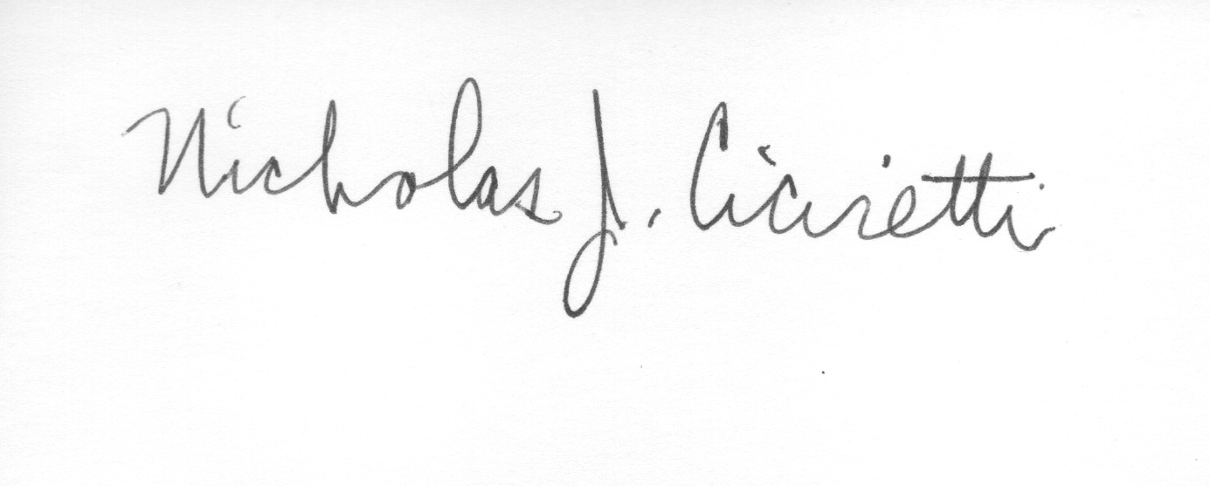
Nick Ciciretti
Secretary

Attachments: Resolution – IRS Ruling 70-604 Election

Directors Meeting
Election of Officers

A brief Directors Meeting was held immediately after the Annual Meeting at 8:05 PM in the community room. The following officers were elected for the coming year:

Jim Zafirson, President
Jeff von Munkwitz-Smith, Treasurer
Nick Ciciretti, Secretary

The meeting was adjourned at 8:45 PM.

Nick Ciciretti
Secretary

