Directors Meeting Minutes
Promenade Towers
October 27, 2022

Directors present: Jim Zafirson, Jeff von Munkwitz-Smith, Judy Katzel, Gregg Turley, Jim Gwilym, Nick Ciciretti, Jeanette Haskell-Property Manager

Director absent: Andy Glassberg

- The meeting was called to order at 7:00 PM.

- The meeting minutes from July 21, 2022 were approved as written.

- Treasurer’s Report:
  - Jeanette Haskell presented a summary of our income and expenses through June. The Operating account balance was $43,708.39 and the Reserve balance was $777,736.28 as of September 30, 2022. The monthly financial statement was approved. In order to balance our operating budget with the anticipated higher costs due to inflation, funds previously directed to the reserve funds are now being added to the operating income. This adjustment minimized the monthly fee increase despite the current inflation rate.
  - Budget for 2023 – The budget was presented and discussed. There were several suggested and agreed upon format changes. A motion was made, seconded and approved unanimously to approve the operating budget. A motion was made, seconded, and approved unanimously to accept the reserve budget, with the understanding that the reserve budget is a guideline which would still require discussion and approval of monies set aside. The budget will be sent to owners with a proxy form to allow voting in advance of the November meeting. The budget is formally approved unless 2/3 of the owners vote no on its acceptance.

- Unfinished Business:
- Remodeling policies – Nick shared with the board a package of forms/documents which Jeanette has been providing to owners with planned remodeling of units. After some discussion it was decided that Nick and Jeanette would make changes to the package and present it to the board at the next meeting. If approved, it would be incorporated into the appendix of the Rules and Regulations.
- Electric car charging station – Gregg presented a proposal for several options of charging stations, including projected installation costs and estimates of future operating costs and revenue generated. It was noted that first-year leasing costs would be included in the initial capital expenditure taken from reserve monies but that, in future years, if income generated does not cover costs of leasing charging stations, monies would come from the operating budget and could require greater monthly fees paid by owners. Any income generated in excess of leasing fees would go back into reserve funds to pay back the initial capital expenditure. A financial estimate indicated that the break-even point to cover operating expenses is 4 users. Several owners noted that they are not in favor of all owners subsidizing something that may be used by few owners, with one owner suggesting that all operating costs be completely borne by users, so as to not add a new operating budget expense. After additional discussion and answering of questions from owners in attendance, a motion was made, seconded, and approved by a 4-2 vote to earmark $31,000 to be spent on a charging station, with the understanding that this does not represent final approval of the project. There will be a final presentation and vote at the January 2023 board meeting.

- New Business:
- Combining November/December Board meetings – A motion was made, seconded, and approved unanimously to combine the November and December meetings into a meeting on November 17.
- Closing date for grill/fire pit – This will be added to the agenda of the November 17 meeting and decided at that time.
- Review of annual meeting– Tabled until the November 17 meeting.
- Energy management system – Jim Z talked about having a building-wide energy management system audit done by EMC. This would include review of lighting, hallway heaters, and overall energy usage in the building. A proposal will be forthcoming.

- Property Manager report:
  - Digital Sky put new metal on the pool gate. The gates are not closing properly. This will be looked into in the spring, along with the fence and light poles which are currently leaning.
  - Unit #228 railing has been repaired. The railing was painted and will serve as a test for painting of all deck railings next year.
  - McGarvey installed rip-rap behind the pool and down the hill to Eastern Promenade to address erosion.
  - There were several fines imposed for: sheet rock dust in the hallways and elevators, move in/move out with no notice, violation of construction/remodeling rules, moving of car stops and parking too close to the building, and contractors parking in the loading zone for extended periods of time.

- Meeting was adjourned at 8:30 PM.

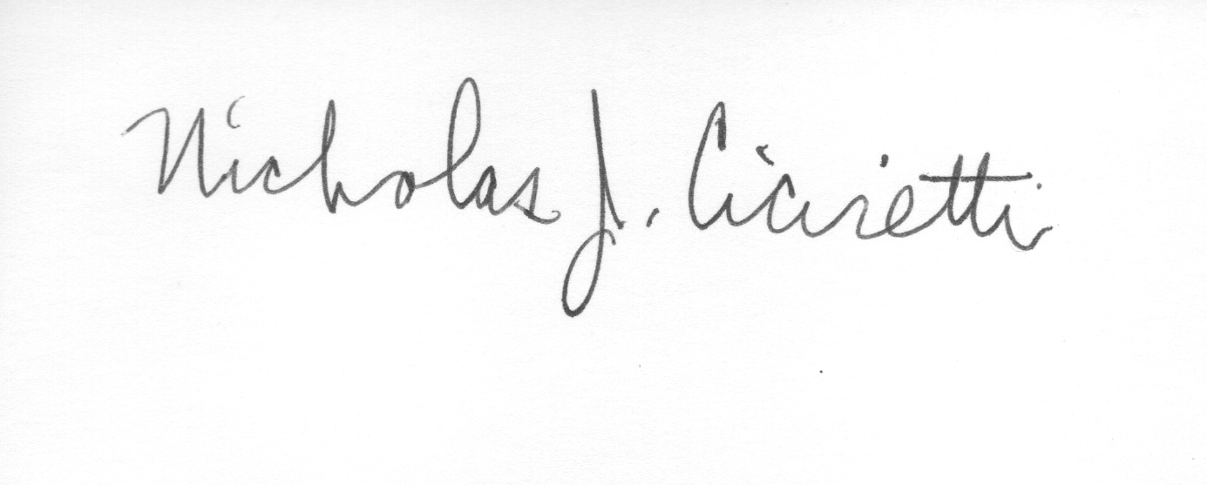

Nick Ciciretti
Secretary

