Directors Meeting Minutes
Promenade Towers
November 17, 2022

Directors present: Jeff von Munkwitz-Smith, Judy Katzel, Gregg Turley, Nick Ciciretti, Jeanette Haskell-Property Manager

Directors absent: Jim Zafirson, Andy Glassberg, Jim Gwilym

- The meeting was called to order at 7:00 PM.

- The meeting minutes from October 27, 2022 were approved as written.

- Treasurer’s Report:
  - Jeanette Haskell presented a summary of our income and expenses through October. The Operating account balance was $45,747.92 and the Reserve balance was $777,389.87 as of October 31, 2022. The monthly financial statement was approved.

- Property Manager report:
- Atlantic Air submitted a quote to clean dryer vents in all units for $30,000. An alternate possibility is to have R & E clean dryer vents in the lowest 4 units in buildings 1 and 2 (8 units total).
- A new toilet has been installed in the fitness room bathroom.
- There is a significant increase in the fee for the Association’s insurance policies. In anticipation of an increase, the amount budgeted for 2023 was $51,000. However, the actual fee will be in the range of $57,000. This is due to our recent history of significant claims in the last three years. Jeanette was able to secure some credit for having a fob entry system as well as a fire alarm system connected to the fire department.

- Unfinished Business:
- Budget for 2023 – The budget approved by the board at the October 27 board meeting was sent to all owners, along with a proxy for voting. Jeanette received 24 proxies, with 22 yes votes and 2 no votes. Since the budget is automatically approved unless 2/3 of ownership votes no, the 2023 budget is now approved. The budget was carefully prepared and the monthly fee increase was kept to 3% in spite of the fact that inflation rates for 2022 are in the range of 8-9%. It was noted that, because of the unanticipated additional increase in insurance fees (noted above) the budget may need to be amended during 2023.
- Remodeling policies – Nick shared with the board the updated package of forms/documents, which include suggested changes discussed at the October 27 board meeting. After discussion there were several additional minor changes. A motion was made, seconded, and approved unanimously to approve the remodeling package with those suggested changes. Nick will make the changes and add the documents to the Rules and Regulations (in the Appendix), along with the City of Portland requirements.
- Closing date for grill/fire pit – The grill and fire pit are closed as of November 15.
- Review of energy management – Tabled until the January meeting.

- New Business:
- Investment policy – Tabled until the January meeting.
- Gregg noted that Barbara (one of the KN Gee cleaners working at PT) has undergone surgery and will not be returning until late December. He circulated a card for Barbara for people at the meeting to sign.
- Fitness room changes – Will Kamal (a unit owner) presented information with costs to remove/replace the universal machine with 3 machines geared to specific muscle groups. He felt that this would encourage use of the fitness room. Depending on which of the three most well-known companies provided the machines, the costs would range from $17,000-$43,000. The information was presented for the board’s consideration.
- Lights/windows in the hallways – It was noted that windows are occasionally left open. Jeanette raised the possibility of having one “monitor” for each floor to check that windows are closed and that all lights are operational (all lightbulbs burned out have been recently replaced). There was no final decision on this item.

- The board went into executive session at 7:45 to discuss an owner issue. The executive session ended at 8:00, at which time the meeting was adjourned.

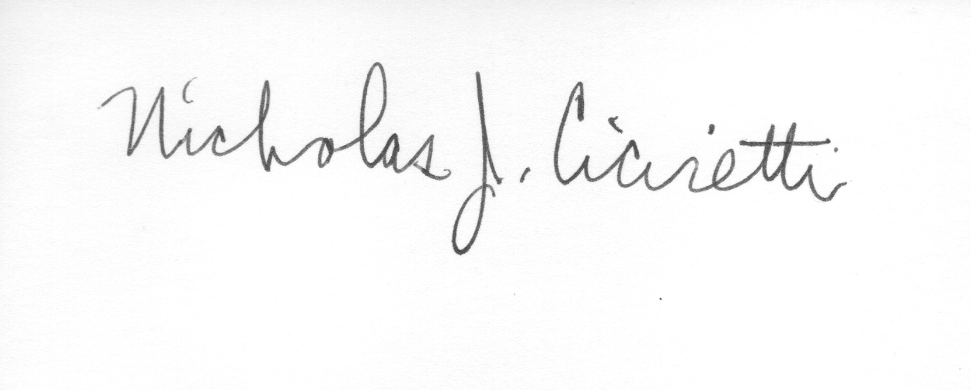

Nick Ciciretti
Secretary

