Directors Meeting Minutes
Promenade Towers
July 21, 2022

Directors present: Jim Zafirson, Andy Glassberg, Judy Katzel, Gregg Turley, Jim Gwilym, Nick Ciciretti, Jeanette Haskell-Property Manager

Director absent: Jeff von Munkwitz-Smith

- The meeting was called to order at 7:00 PM.

- The meeting minutes from June 16, 2022 were approved as written.

- Treasurer’s Report:
  - Jeanette Haskell presented a summary of our income and expenses through June. The Operating account balance was $25,174 and the Reserve balance was $764,186 as of June 30, 2022. The monthly financial statement was approved.

- Unfinished Business:
- Pool intruders/pool security – There have been several incidents recently (both overnight and during the day) of intruders climbing the fence near the pool shed or reaching through the front gate to open it, and using the pool. This has caused some damage to a vent located on the side of the pool shed. In several of those cases 911 calls were made. In at least one of those calls police never responded by coming to Prom Towers, they just called back later to see if intruders were still there. There was much discussion about how best to address these ongoing violations of property, security, and safety. It was noted that if anyone sees/hears intruders in the pool area, either during the day or after 10:00 pm, a call to 911 should be immediately made. Police have indicated that if there is not an ongoing emergency at the time of the call, they will respond. A motion was made, seconded, and approved unanimously to spend approximately $500 (quote from Digital Sky) for better gate security (expanded screen to prevent reach-through at front gate) and $200 for “no trespassing” signs. Additionally, Jeanette will explore other options (motion sensor lights with or without audible alarms and flashing lights, night vision cameras, etc.).
- Deck repair – Jeanette said that Knowles is set up to do deck repair on unit #225 in July, and will also be working on two other decks. These are all decks most recently recoated by Capozza. Capozza will be contacted about fixing the decks that they improperly recoated in 2018.
- Realignment of light pole(s) in pool area – Jeanette said that she is still awaiting a quote for this.
- Remodeling policies – Jim Z noted that the policies are a work in progress. The association does not want to micromanage projects, but rather to develop rules which address any work which might impact any unit other than the unit being renovated. This includes fire safety (e.g., no wood in wall cavity and no removal of fire-rated insulation without replacement), potential water issues (from improper plumbing), electrical issues, or sound issues (from improper soundproofing), etc. Projects might ultimately include inspections by a third-party licensed building inspector. Jim is awaiting an opinion from our attorney as to whether this might be charged back to the unit owner where the renovation is taking place. Jeanette currently meets with contractors prior to renovations and goes over a contractor checklist that she developed. Development of the policies will continue and, when approved, will be added to the Rules and Regulations.
- Electric car charging station – There was discussion on the results of the survey which had been sent to all owners. Those survey results were recently sent to the board and to unit owners. After discussion about some of the survey numbers and comments (both positive and negative), as well as some discussion on the various options if the project moves forward (no. of stations/above ground vs. below ground, etc.), it was decided that all the compiled information from proposed vendors would be resent to the board so that next steps may be taken as to whether to, and when to, move the project forward. This will give the board additional time to review the survey and to explore unanswered questions, such as how best to cover operating costs.

- New Business:
- Dissemination of minutes – Nick noted that currently meeting minutes are not posted on the website until the board has approved them. This means, for example, that minutes of the June meeting are not posted until after the July meeting (more than a month later). He asked if the board would agree that he can post minutes (marked “draft”) on the website once the board has had several days to review the draft. The board agreed to this.
- Budget voting by proxy – Currently the budget is presented to the board at the October meeting and, if approved, gets sent to the owners. The budget is automatically ratified at the November meeting unless 2/3 of the owners reject it. Nick, Jeff, and Jeanette have discussed the possibility of a proxy voting form being included with the budget when it is sent to owners. This would give owners a more formal opportunity to vote on the budget. A motion was made, seconded, and approved unanimously to make this change starting this year.
- Electrical conduit and lights in the parking area – There is significant rusting of exposed metal in covered parking areas along with some lights which are loosely secured. Jeanette was asked to get a quote from Knowles to blast and recoat exposed metal and to also get a quote for LED replacement lights along with PVC electrical conduits.
- Pool temperature – After discussion it was decided that the pool temperature should be set to 78 degrees.
- Apartment fire in the Bronx – A resident/owner asked if a newspaper article could be shared with the board regarding a recent, deadly apartment fire in the Bronx. The board agreed.

- Property Manager report:
  - Regarding a proposed bathroom renovation in unit #136, there is still information being gathered, so the plan was not approved as yet.
  - After discussing possible replacement of hallway heater thermostats, it was decided to explore having an energy management survey done first to determine what other options there might be.
  - Steve Schools will be testing a product on deck railings which he has used before at other locations.
  - Jeanette is still awaiting Cummins to set up an inspection of the current fire pump for possible replacement.
  - New water pumps will be installed at some point in the near future.
  - Still awaiting restringing of one of the pool umbrellas.
  - KN Gee will be scrubbing and waxing stairwells that had not previously been done.
  - New signs are in place for the grill and fire pit area except for an emergency sign on pool shed for resetting the fire pit.
  - Still exploring having dryer vents cleaned. Company that did it previously is out of business.
  - The new office computer has arrived at R & E but the software necessary for the fob system has not yet arrived.
  - There was one fine for a tenant moving out and using the mailroom exit instead of the service exit.

- Meeting was adjourned at 8:05 PM.

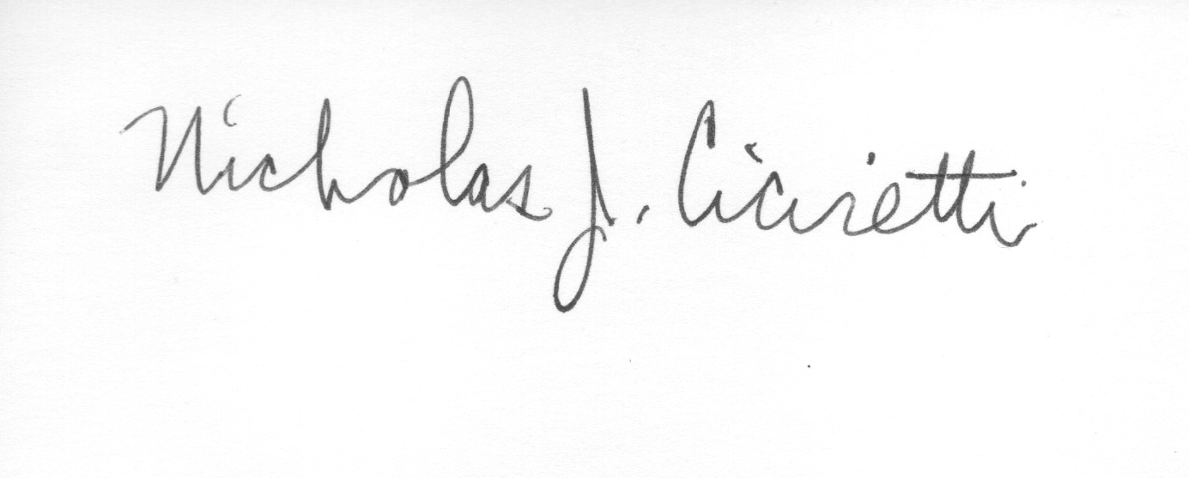

Nick Ciciretti
Secretary

