Directors Meeting Minutes
Promenade Towers
January 19, 2023

Directors present: Jim Zafirson, Jeff von Munkwitz-Smith, Andy Glassberg, Judy Katzel, Gregg Turley, Jim Gwilym, Nick Ciciretti, Jeanette Haskell-Property Manager

- The meeting was called to order at 7:00 PM.

- The meeting minutes from November 17, 2022 were approved as written.

- Treasurer’s Report:
  - Jim Gwilym presented a summary of our income and expenses through December. The Operating account balance was $36,546 and the Reserve balance was $794,968 as of December 31, 2022. Jim noted that we were over budget on electricity costs due to our contract running out, but that it has now been renewed. The monthly financial statement was approved.

- Property Manager report:
- The fire pump batteries need to be replaced. A motion was made, seconded, and approved unanimously to approve an expenditure of $5000 for their replacement.
- The fire pump needs to be replaced, following a recent inspection. Jeanette is attempting to have a Cummins representative visit in advance of their preparing a quote. Jim Z will be here when the meeting is scheduled. Jeanette will also be getting several quotes to replace the sprinkler system as well (this is a separate part of the fire pump/sprinkler system).
- Several units have had the felt stripping between windows degrade, allowing cold air and moisture/water to penetrate. Jeanette will explore replacement options.
- Software for the front entry door/phone number system has been installed on the new computer.
- Unit #157 has received a letter regarding violations and fines related to renovation work. Some money is still owed on the fines. Interest and late fees will now be charged. A request will be made to the owner for a copy of the electrical permit obtained from the City of Portland. Also, an inspection will be necessary to verify that any violations of Rules and Regulations for renovations have been rectified.
- Dryer vents on the lowest level will be vacuum cleaned by R & E personnel.

- Unfinished Business:
- Investment policy – After discussion, a motion was made, seconded, and approved unanimously to adopt the investment policy [see below], set up a brokerage account with the board president and treasurer as signees, and invest up to $500,000 of reserve fund monies in US Treasury bonds.
- Fitness equipment update – Tabled until next meeting.
- Fire hydrant replacements – Neither of our two fire hydrants are operational. E. J. Prescott can’t get parts but could replace the hydrants (but not do any excavation). Wilson excavation and Keenan excavation are two possible contractors for the excavation piece.
- Review of energy management – There will be an onsite meeting next week to begin the process, including the feasibility of installing heat pumps to replace all electric hallway heaters. If this can be done, there would be a significant reduction in electricity costs for building heating.
- Sprint decommissioning/reroof area – Most of the equipment to be removed is on the elevator tower. Because of this, when the entire building roof was replaced several years ago, this area was not reroofed. It is now leaking and, once the Sprint equipment is removed, a new roof will be installed. Sprint will continue to pay rental charges until their equipment is removed. There is other upgrade of equipment pending.
- Update on electric car charging station – Gregg indicated that he has gotten two additional quotes for the electrical work need in advance of installation of stations. Mancini’s quote was approximately $50,000, while the quote from Casco Bay was approximately $30,000 (in the range of the earlier quote from LaPlante). Due to significant anticipated costs for highest priority, safety needs (replacement of fire pump/sprinkler system and fire hydrants), the possible installation of car charging stations is of lower priority at this time.
- Update of lobby furniture – Judy indicated that she will be getting quotes from Hub, Jordan’s, and Young furniture companies for replacement of pieces for the lobby. If new furniture is purchased, the current furniture would be moved to the library. Replacement of furniture will also be considered only when highest priority needs are met.

- New Business:
- Hot water heater shutoffs/pans – Under our current policy automatic hot water heater shutoffs are required for all new hot water heaters (only HTP stainless heaters are approved). There was discussion as to whether an electricity shutoff to the heater should be required (Watts shutoffs do cutoff power, while Taco shutoffs don’t). It was decided that power doesn’t necessarily have to be shutoff. Regarding drip pans, it was decided that pans should be metal, not plastic.
- There was a leak into unit #257 from unit #258. The unit owners have resolved any outstanding issues regarding damage to unit #257.
- Dirigo Property Management has bought R & E Property Management, effective February 1, 2023. There are no immediate issues anticipated at this time from the change.
- Damage to deck in unit #155 – Jeanette shared pictures of the damage. When weather permits, silicone sealant will be applied to prevent further damage from water incursion. Additional steps may be necessary.
- Intruder in middle lot – There was a non-resident vehicle recently with intruders. Gregg shared their license plate number with Jeanette, but it is not believed that they were the same intruders who had previously received a warning from the police.

- The meeting was adjourned at 8:10.

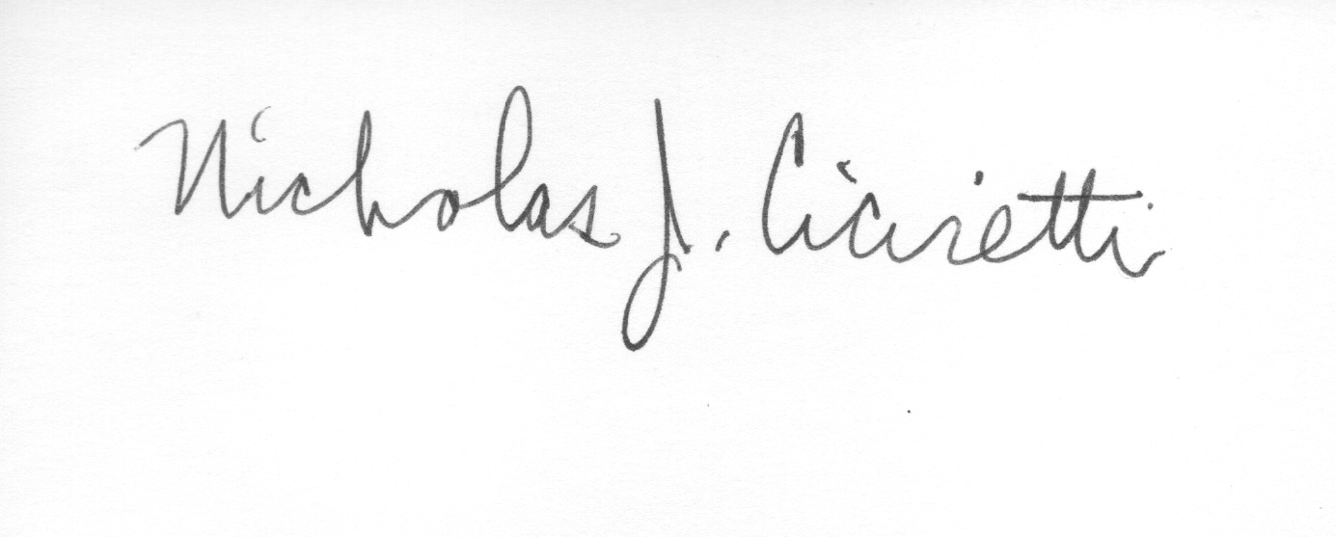

Nick Ciciretti
Secretary

Promenade Towers
Investment policy

Objectives:
- Earn a reasonable amount of interest on our funds
- Protect principal
- Maintain strong internal controls

Investment Guidelines:
- Invest only in securities backed by the US Government or other Federally insured deposits.
- Decisions about maturity dates shall be planned to maximize interest without risking significant losses for early withdrawals. The Board shall be notified immediately of any losses resulting from penalties or early withdrawals.
- The Board shall continuously ensure that the individuals making investment decisions have the appropriate level of expertise, and seek professional advice when warranted.

Appropriate use of funds:
- Costs of projects approved by way of the Reserve budget
- Costs of other projects approved by a vote of the Board
- Advances to the Operating account to cover short-term needs resulting from budgeted expenses incurred ahead of a straight-line budget. All Board members are to be notified of any such advances.

Safeguards:
- The Board shall determine which individuals are authorized to initiate any transactions in our accounts.
- All authorized signers shall receive automatic notification of all transactions by text or e-mail.

Reporting requirements:
- The Treasurer shall report at each Board meeting about Reserve transactions and the rate of interest earned.
- All authorized signers shall receive copies of brokerage account statements

