Directors Meeting Minutes
Promenade Towers
March 16, 2023

Directors present: Jim Zafirson, Jeff von Munkwitz-Smith, Andy Glassberg, Gregg Turley, Jim Gwilym, Nick Ciciretti, Jeanette Haskell-Property Manager

Director absent: Judy Katzel

- The meeting was called to order at 7:00 PM.

- The meeting minutes from January 19, 2023 were approved as written.

- Treasurer’s Report:
  - Jim Gwilym presented a summary of our income and expenses through February. He noted that electricity costs have been significantly higher than anticipated. The Operating account balance was $23,605 and the Reserve balance was $836,597 as of February 28, 2023. The monthly financial statement was approved.

- Property Manager report:
- Burns Fencing was onsite to look at the work needed to realign/repair the pool fence and will provide a recommendation.
- Unit #212 had a fire door replaced in the dryer vent stack which had been causing condensation from the dryer to back up into the unit.
- Dirigo Property Management will be charging $100/year for any Association accounts not held at Citi Bank.
- The cause of the leak into unit #257 has not yet been identified.
- The fire hydrant by the lower parking lot entrance has been serviced and is now operational. The hydrant by the smoking area at the end of building #2 is not working and needs extensive repair. Current quotes were discussed but no final decision was made, pending additional information not received as yet.
- We have received a quote from Sprinkler Systems to replace and re-pipe the fire pump/sprinkler system, which ranges from $197,000-$225,000 depending on final work necessary. After discussion, it was decided to obtain answers to some questions generated at this meeting before proceeding.
- There are leaks in units #214 and #234, the source of which has not yet been identified.
- The emergency generator is now automatically being tested weekly. It is believed that error codes (unidentified) were the cause of the generator not coming online earlier this year when the power went out. Because of that, the elevator did not properly go to ground . An owner was stuck in the elevator and released by the fire department. The fire department now has the correct fob for the knox box in the lobby foyer. Also, an elevator key has been placed in the elevator room to replace the one that was missing.
- There is a new KN Gee employee (Nicole) doing building cleaning on Monday, Tuesday, Thursday, and Friday.
- A Dirigo maintenance person will now be doing Prom Towers maintenance. All work requests must go through Jeanette and not directly to the maintenance person.
- Steve Schools will be repairing ceilings damaged by the sprinkler leak earlier this winter.
- There were two fines, a $250 fine for violation of the remodeling policies (not the first violation by the contractor working on this unit) and a $25 fine for violation of the recycling rules (not breaking down a cardboard box).

- Unfinished Business:
- Fire pump replacement – covered above.
- Fire hydrant replacements – covered above.
- Review of energy management – Jim Zafirson will be meeting onsite next Thursday with a company specializing in mini-split heat pumps to determine their feasibility as hallway heaters. If that is not feasible, the control system for the current heaters will be changed to better manage supply of heat and use of electricity.
- Sprint decommissioning/reroof area – This is still open; we have not received a plan as yet.
- Update of lobby furniture – We have received quotes, but no action is being taken at this time due to uncertainty regarding large capital investments pending.
- Fitness equipment update - No action is being taken at this time due to uncertainty regarding large capital investments pending.

- New Business:
- Sprinkler system/damage from excessive cold – We have not received the bill as yet from Sprinkler Systems for their work. Sprinkler Systems is responsible for damage repair to the grounds, which came from their vehicles during the sprinkler emergency.
- Remote attendance at board meetings – After some discussion about the possibility of having board members join board meetings by Zoom, it was decided that board meetings would not be conducted using Zoom. It was recognized that, although all board members must occasionally miss a meeting, attendance is necessary for full participation.
- Limiting the use of emails – It was noted that emails amongst board members and the property manager should only be used for informational purposes and not to conduct board business or share opinions on matters under consideration, unless a mid-month board vote must be made (such votes must be unanimous for approval and are then reported at the next board meeting, so as to be memorialized for the minutes). The board recognizes the importance of conducting board business at open board meetings.
- It was decided that the signees on the Schwab brokerage account which will be opened for Association investments will be the three Association officers (President, Treasurer, and Secretary).

- The meeting was adjourned at 8:05.

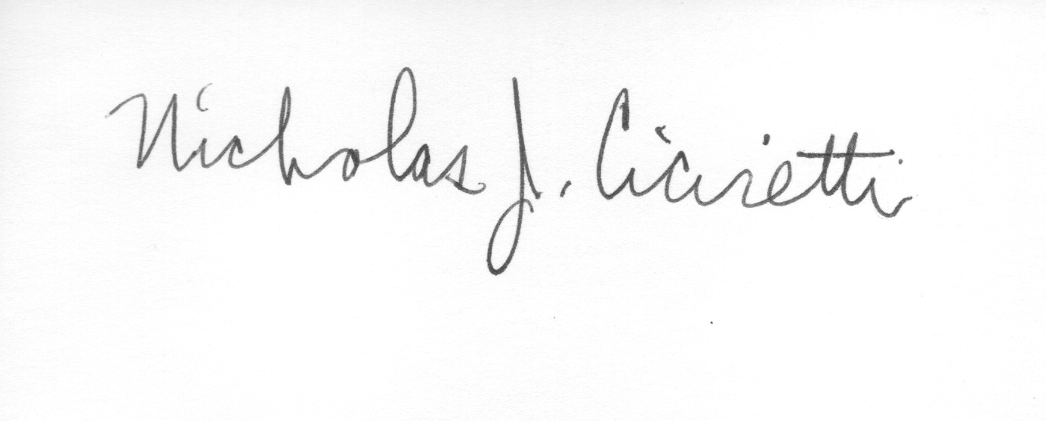

Nick Ciciretti
Secretary

