Directors Meeting Minutes
Promenade Towers
April 20, 2023

Directors present: Jeff von Munkwitz-Smith, Andy Glassberg, Judy Katzel, Nick Ciciretti, Jeanette Haskell-Property Manager

Directors absent: Jim Zafirson, Jim Gwilym, Gregg Turley

- The meeting was called to order at 7:00 PM.

- The meeting minutes from March 16, 2023 were approved as written.

- Treasurer’s Report:
  - Jeanette presented a summary of our income and expenses through February. She noted that electricity costs have been significantly higher than anticipated. There was a question about the possibility of using solar credits to reduce electricity costs, but that was determined not to be advisable due to the possibility of dramatic increases later. The Operating account balance was $9707 and the Reserve balance was $841,343 as of March 31, 2023. There was also a question as to why the previously board-approved investments of reserve funds in Treasury instruments had not been initiated. The monthly financial statement was approved.

- Property Manager report:
- Burns Fencing was onsite to look at the work needed to realign/repair the pool fence and straighten the light poles. A quote has not as yet been given. There is concern about opening the pool before the fence and gate are repaired and secured.
- There will be a meeting with Sprinkler Systems on May 12 at Promenade Towers regarding replacement of the fire pump.
- Fire extinguishers were serviced. They will need to be replaced next year at a cost of approximately $32,000; service is usually $16,000. Due to the age of the extinguishers they cannot be serviced again as they have reached the end of their useful life.
- There was a power outage during service on the emergency generator resulting in the elevators temporarily being inoperative.
- New window washing options are being explored, since local ordinances have changed about having contractors physically working on the outside of the building.
- Air conditioning servicing will be available in June.
- There was some damage to the grounds done by Sprinkler Systems when their emergency sprinkler service was necessitated during the extreme cold earlier in the winter. The cost will be approximately $500. A motion was made, seconded, and approved unanimously to have the Association absorb that cost.

- Unfinished Business:
- Fire pump replacement – covered above.
- Fire hydrant replacements – The cost to upgrade the two fire hydrants is approximately $12,000. A motion was made, seconded, and approved unanimously to approve that amount for the project.

- New Business:
- Jeff von Munkwitz-Smith announced that this will be his last official meeting as a board member, since he and Lesa will be closing on the sale of their unit in mid-May and moving in July. The board officially thanked Jeff for all his work on behalf of the Association as a board member and Treasurer.
- The meeting was adjourned at 7:35.

n.b. Several days after the meeting, Jeanette obtained a figure of $13,866 to upgrade the fire hydrants.

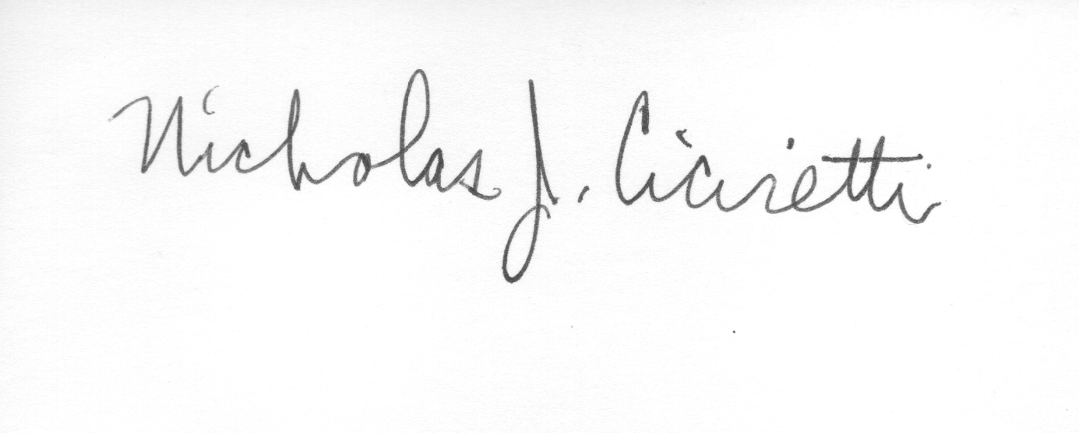

Nick Ciciretti
Secretary

