Directors Meeting Minutes
Promenade Towers
May 18, 2023

Directors present: Jim Zafirson, Andy Glassberg, Judy Katzel, Gregg Turley, Jim Gwilym, Mark Rockwood, Nick Ciciretti, Jeanette Haskell-Property Manager

- The meeting was called to order at 6:30 PM.

- Fill board of directors vacancy- A motion was made, seconded, and approved unanimously to have Mark Rockwood fill the remainder of the term made available by the resignation of Jeff von Munkwitz-Smith.

- The meeting minutes from April 20, 2023 were approved as written.

- Treasurer’s Report:
  - Jim Gwilym presented a summary of our income and expenses through April. He noted that electricity costs have been significantly higher than anticipated. The Operating account balance was $1876 and the Reserve balance was $837,352 as of April 30, 2023. A motion was made, seconded, and approved unanimously to transfer $25,000 from reserve funds to the operating fund, with the expectation that the funds would be repaid to reserves by the end of the year. The monthly financial statement was approved.

- Property Manager report:
- Burns Fencing will be onsite Friday, May 19 for the first part of the pool fence repair and will complete work the following Monday. As a result, the pool and patio will not be open until May 31, unless Christman Pools has a cancellation to slot us in earlier.
- The unit #155 owner plans to replace his air conditioner unit. The contractor raised the possibility of cutting access panels in the hallway as part of the work. Jim Zafirson pointed out that access panels can be cut inside the unit so as not to disturb the hallway (which would require repatching/repainting). Jeanette will relay that information to the unit owner.
- Work on the fire hydrants will begin on June 8.
- The summer party will be on June 21.
- There is a leak in the building #1 stairwell on the 5th floor. The plexiglass panel will be removed, the leak repaired, and the panel resealed.

- Unfinished Business:
- Fire hydrant replacements – covered above.
- Fire pump replacement– There was a meeting with Sprinkler Systems on May 12 to discuss possible replacement of the engine and fire pump. There are three possible options: 1) install an updated system, 2) install an engine and pump matching the current equipment, and 3) rebuild the existing system. Additional information will be gathered before any final decision will be made. It was noted that, in the event of an emergency, the fire department pumper trucks have the capability to charge the current sprinkler system.

- New Business:
- Fire Marshal’s report- The report outlined a series of actions that Prom Towers needs to take over the course of 6 months to 12 years, depending on the specifics of the requirements. The Association has retained an attorney who will be preparing an appeal of the entire report (the appeal would be heard by the zoning board of appeals). As a result of making an appeal, no actions will be taken at this time. A motion was made, but not seconded or voted on, to provide the attorney with specific information about Portland’s requirements. Another motion was made, but not seconded or voted on, to provide owners with a copy of the Fire Marshal’s report. It was noted that owners may request to see the report.
- The unit #251 owners questioned the fine and the process of receiving the notice of fine, that they had previously received for moving the parking curb and parking their car against the building wall. Jim Zafirson explained the reason the rule was originally put in place (damage to the building wall), that the rule (as all rules) must be obeyed without exception, and that there was nothing personal in the fine. The unit owners also brought up their concern about having electric bicycles in the storage room due to possible battery fires. It was noted that electric bike batteries are typically removed for separate recharging, and that the bike room is self-contained with sprinklers in the event of a fire.

- The meeting was adjourned at 7:25.

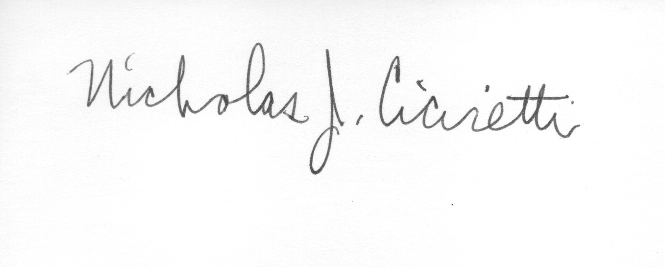

Nick Ciciretti
Secretary

