Directors Meeting Minutes
Promenade Towers
June 15, 2023

Directors present: Jim Zafirson, Andy Glassberg, Judy Katzel, Gregg Turley, Jim Gwilym, Mark Rockwood, Nick Ciciretti, Jeanette Haskell-Property Manager

- The meeting was called to order at 6:30 PM.

- The meeting minutes from May 18, 2023 were approved as written.

- Treasurer’s Report:
  - Jim Gwilym presented a summary of our income and expenses through May. The Operating account balance was $23,470 and the Reserve balance was $818,925 as of May 31, 2023. It was noted that there is a favorable variance in reserves due to T-Mobile/Sprint paying six month’s rent as termination fee along with their regular monthly fee from January through April. It was also pointed out that they must continue to pay rent until all their equipment is removed from the roof. The monthly financial statement was approved.

- Property Manager report:
- There was discussion about the pool not being open yet due to the ongoing issue with the front gate and fence. It was decided that, until the fence/gate work is completed, pool access will be through the gate at the patio/grill entrance using keys. Jeanette will have 20 keys made and will notify owners of their availability. Jim Gwilym will distribute keys the day after the board meeting. The grill and fire pit will not be used until front gate fob access is available.
- Work on the fire hydrants has been completed. The riser on the hydrant at the service entrance has been installed and the hydrant is operational. There was a shutoff found buried beneath the pavement near the hydrant in the middle lot. This meant that a sleeve/shutoff was not required to be installed as previously expected. As a result, the bill for that part of the work was $500 instead of the originally quoted amount of $6500. The hydrant was removed for repair. A motion was made, seconded, and approved unanimously for a $1000 expenditure to cover cost of hydrant repair.
- AppFolio has given notice to Dirigo that they will be charging $2.49/month for condo fee payments through AppFolio, effective July 1. Jeanette will explore other options to make the payments.
- There was discussion about the quote from Atlantic Air Duct to clean and test air ducts in all the units. It was noted that this is an Association responsibility. A motion was made, seconded, and approved unanimously for a $4200 expenditure (from reserves) to have this work done. If testing shows improper flows, monies for additional work would have to be approved separately.
- A stolen vehicle was found in the middle parking lot. The vehicle was removed by police. Yarmouth police department is reviewing the PT videos.
- There was an intruder in the foyer area at the mailroom entrance. A resident called the police who came and escorted the individual off the property.

- Unfinished Business:
- Fire hydrant replacements – covered above.
- Fire pump replacement – There was an inspection of the pump. A quote of $12,000 has been received to replace the pump. There will be a test of the diesel engine to determine next steps.
- Fire Marshal’s report- The lawyer retained by the Association has filed an appeal of the entire report.
- Stairwell repainting – There was discussion about the condition of the stairwells and the need to repaint some or all of them. There had been a quote last year from Steve Schools of $34,400 to completely repaint all three stairwells. It was decided that Jeanette and Nick will walk the stairwells to determines which areas were most in need of repainting and obtain a new quote from Steve Schools to bring back to the board.
- Spending priorities – There was some discussion of spending priorities in general and the need to carefully spend money based on some of the uncertainties that PT faces.
- Lobby furniture replacement – Judy reviewed the quote of $15,000 she had previously received from Hub Furniture for new furniture in the lobby. Under this plan the current lobby furniture would be placed in the library. A motion was made, seconded, and approved unanimously to approve an expenditure of $15,000 for furniture from Hub Furniture, with the understanding that Judy will obtain samples for review by the board prior to final selection.
- Electric vehicle charging station – Mark will be obtaining some additional information on options to bring back to the board.

- New Business:
- An owner who recently had a new hot water heater installed inquired whether the replacement plan/schedule of hot water heaters was still in force. Jim Z stated that the current rules are absolutely still in effect.
- A resident noted that there have been several incidences of unreported coffee spills in the building 2 hallway on the 4th floor and asked if the Association would consider purchasing a portable carpet cleaner to handle such events. Jeanette will look into this.

- The meeting was adjourned at 7:35.

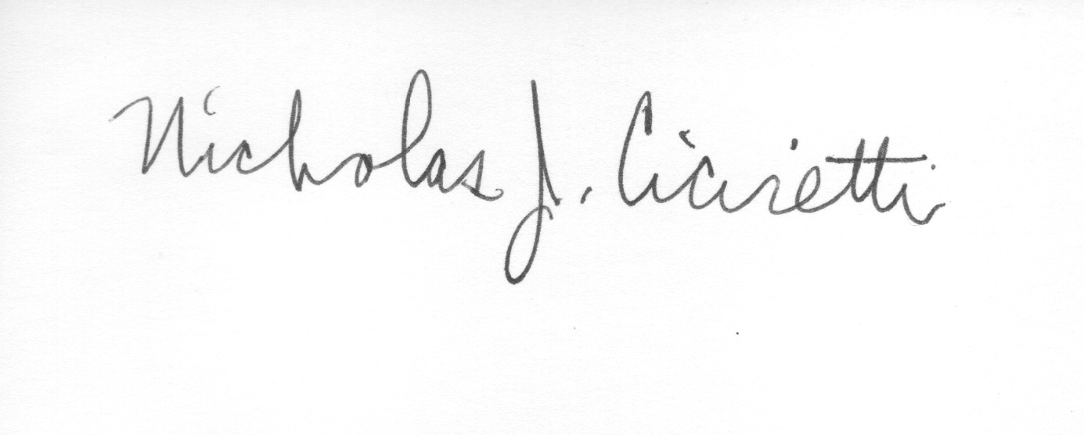

Nick Ciciretti
Secretary

