Directors Meeting Minutes
Promenade Towers
July 20, 2023

Directors present: Jim Zafirson, Andy Glassberg, Judy Katzel, Gregg Turley, Jim Gwilym, Mark Rockwood, Nick Ciciretti, Jeanette Haskell-Property Manager

- The meeting was called to order at 6:30 PM.

- The meeting minutes from June 15, 2023 were approved as written.

- Treasurer’s Report:
  - Jim Gwilym presented a summary of our income and expenses through June. The Operating account balance was $29,723 and the Reserve balance was $813,564 as of June 30, 2023. The monthly financial statement was approved.

- Property Manager report:
- The main item noted was that the pool fence/gate repairs have essentially been completed and the fob re-installed. The only work remaining is surface repair in front of the gate.

- Unfinished Business:
- Mid-month decisions – There were three mid-month decisions made by the board: 1) authorizing an expenditure for the diesel engine technician ($600), 2) closing Key Bank accounts, and 3) authorizing the expenditure for the pool fence/gate repair (approximately $10,000).
- Fire hydrant replacements – The company doing repairs is waiting for parts before completing their work.
- Fire pump replacement – A diesel engine technician will be evaluating the engine while the sprinkler system is under load to help determine next steps.
- Fire Marshal’s report- There is nothing new to report.
- Stairwell repainting – After making a tour of the stairwells with Steve Schools it was determined that the best approach is to address one stairwell at a time from top to bottom. It was decided to work on the center stairwell first since that is the one most in need. Since Steve had originally given a total price for all three stairwells of $34,400, Jeanette will ask him for a price for just the center stairwell, then the board will vote on that. Work would be scheduled (most likely) for October to allow the center stairwell to be used for removal of cell phone equipment by T-Mobile/Sprint.
- Lobby furniture replacement – Judy showed samples of fabrics and rugs she obtained from Hub Furniture (along with pictures). There were two different options, differing mainly in the rug choice. The board decided on Option A (pictures available from Jeanette). The cost will be approximately $9000, which is significantly less than the $15,000 previously approved. The current lobby furniture will be moved to the library. The current library furniture will be donated to a refugee support organization.
- Electric vehicle charging station – A motion was made and seconded to approve the expenditure of $31,000 earmarked in the reserve budget, but not previously approved, for La Plante Electric to complete necessary work in support of a level 2 dual charging station in the upper lot, as per their previous quote. There was significant discussion about the merits of this expenditure given other needs of Promenade Towers. In the end the motion was approved by a 4-2 vote.

- New Business:
- Rules for board members acting on behalf of the entire board – Jim Z noted that board members are only allowed to act as board representatives when authorized to do so, and only for specific scenarios. It was decided that correspondence going to outsiders should be reviewed by the board first to prevent further dissemination of misinformation.
- E-bike safety storage – There was a discussion about the pros and cons of allowing E-bikes to be stored and/or have batteries charged in the bike room. No decision was made at this time.
- Restarting welcome committee – Approval was given to restart the welcome committee to meet with new owners and renters. Mark will reach out to find people interested in serving on the committee.
- T-mobile/Sprint equipment removal – Work will commence on July 24. It is expected to be completed by September 8.
- Start time for meetings – After discussion it was decided that monthly meetings will start at 6:30 unless otherwise noted.
- Jeanette will explore the possibility of purchasing an automated emergency defibrillator (AED) for the building.
- A notice soliciting interested parties in running for the board will go out 60 days in advance of the annual meeting. (It will be less than 60 days this year since the annual meeting will be on September 13.)

- The meeting was adjourned at 7:35.

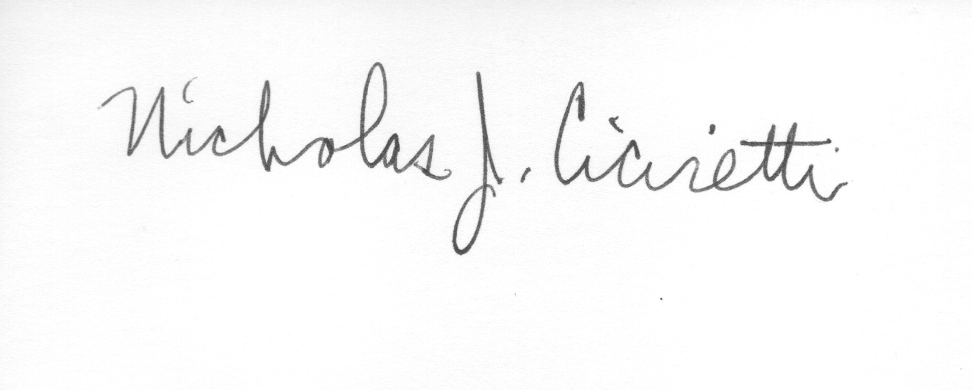

Nick Ciciretti
Secretary

